**A**

**PROJECT REPORT**

**ON**

**THE USE OF ARTIFICIAL NEURAL NETWORK FOR PREDICTION ANALYSIS OF ROAD TRAFFIC ACCIDENTS CAUSES IN AKURE, NIGERIA**

**BY**

**OGUNDELE DENNIS TOSIN**

**EEE/14/7927**

**AS SUPERVISED BY**

**DR. J. J. POPOOLA**

**SUBMITTED TO**

**DEPARTMENT OF ELECTRICAL AND ELCETRONICS ENGINEERING**

**FEDERAL UNIVERSITY OF TECHNOLOGY, AKURE.**

**TABLE OF CONTENTS**

**CHAPTER ONE**

INTRODUCTION

1.0 Background of Study

1.1 Statement of Problem

1.2 Aim of the Study

1.3 Objectives of the Study

1.4 Justification of the Study

1.5 Scope of the Research

1.6 Area of Study

**CHAPTER TWO**

LITERATURE REVIEW

2.0 General

2.1 Transportation and Transportation Systems

2.2 Roles/Importance of Transportation

2.2.1 Historical

2.2.2 Social

2.2.3 Political

2.2.4 Environmental

2.3 Modes of Transportation

2.3.1 Road Transportation

2.3.2 Rail Transportation

2.3.3 Water Transportation

2.3.4 Air Transportation

2.4 The Road Transport Network/System

2.4.1 Advantages of the Road Transport System

2.4.2 Disadvantages of Road Transport System

2.4.3 Road Transport Life Cycle

2.5 The Road Transport System in Africa

2.5.1 Walking

2.5.2 Animal Carriages

2.5.3 Taxi Bikes

2.5.4 Taxi Cabs

2.5.5 Buses and Minibuses

2.6 Factors Responsible for Road Transport Accidents

2.7 Consequences of Road Transport Accidents

2.8 Artificial Neural Network

**CHAPTER THREE**

MATERIALS AND METHODOLOGY

3.0 Materials

3.1 Procurement of Road Traffic Accidents Data

* 1. Preprocessing of Road Traffic Accidents Data

3.2.1 Data Transformation

3.2.2 Data Splitting

3.2.3 Feature Engineering

3.2.4 Feature Selection

3.2.5 Normalization

3.2.6 Feature Extraction

3.2.7 Natural Language Processing (NLP)

3.3 Conceptual Framework of Artificial Neural Network

3.3.1 Feed-Forward Pass

3.3.2 Gradient Descent and Optimization

3.4 Building the Artificial Neural Network (ANN)

**CHAPTER FOUR**

RESULTS AND DISCUSSION

4.0 Exploratory Data Analysis

4.1 Data Analysis

4.1.1 Analysis based on time

4.1.2 Analysis based on Routes

4.2 ANN Predictive Model Result

4.2.1 Comparative Results of Test on the variation of Activation Function

4.2.2 Comparative Results of Test on the variation of Optimizer

**CHAPTER FIVE**

CONCLUSION AND RECOMMENDATIONS

5.0 Conclusion

5.1 Recommendations

REFERENCES

**CHAPTER ONE**

**INTRODUCTION**

**1.0 Background of Study**

Development and urbanization have increased the need for people to move from one place to another, particularly in developed countries. The transport system play a key role in moving people, goods, and services to strategic locations. A good transport system has proven to be a critical criteria for economic development (Mohd, 2011). The road transport system is one of the cheapest and most accessible means of transportation, and this is seen in the increasing number of various vehicles (cars, buses, motorcycles, lorries, and vans) on the roads, to move people and goods to their respective destinations. It is however looking inevitably unfortunate that this increasing number of vehicles on the roads have continually led to loss of lives and properties, via accidents. Many developed countries have stood up and made legislation to combat and mitigate these dreadful cases. Switzerland, in a bid to further reduce risks of road accidents and manage road safety, implemented the three E’s (engineering, enforcement and education) (DFT, 2011), and her road network currently ranks amongst the safest in Europe (Borja *et al.*, 2018).

The current rate and recorded number of road accidents in Nigeria is alarming and very disturbing. Nigeria and several other developing countries have incurred several loss to this road accident menace. In fact, an increased number of road fatal accidents were recorded from 1960 to 1989 (Ogwueleka *et al.*, 2014), with a 500% increment recorded between 1980 and 1989 (Adeolu, 1993). Past studies have shown that over 57,000 deaths were caused by road accidents between 1970 and 1979. More so, increase in these numbers were between 1990 and 1999 with over 76,000 death due to road transport accidents (Osime *et al.*, 2006). In a recent study that included cases of early 2000s, over 270,000 deaths were recorded between 1960 and 2004, and about 845,000 people injured (Ogwueleka *et al.*, 2004). Dreadful! Statistics currently hold that an average of 10,000 Nigerian gets killed by road accidents annually (NPF, 1989). In addition to the loss of lives, road accidents have been proven to grossly affect the social and economic development of Nigeria. It practically costs Nigeria a 13% annual loss of her Gross National Product (GNP) (Ohakwe *et al.*, 2011). Several factors have been established to be responsible for these road accidents. Odumosu (2005) emphasized that about 85% of road accidents in Nigeria are caused by human factors including: drunk-driving; poor driving skills; drugs; health problems; and temperament. Ozgan and Demirci (2008) affirmed that the driver’s behavior; vehicle features; highway and traffic characteristics are factors that could increase the severity of road accidents. Nonetheless, it is laudable that a good number of indigenous researches have ensued to examine the causes of road transport accidents in Nigeria. In particular, Ogwueleka *et al.*, (2014) harnessed the Artificial Neural Network (ANN) to examine the causes of road accidents in Nigeria and predict the rate of future occurrences.

Several models have been developed to examine and predict accident rates over the years. The Bayesian interpretation of probability is a renowned method for such predictions (El-Basyouny and Sayed, 2011). Conventional programming have also proven to be efficient for examination of accident causes. However, ANN has shown an edge over other viable models due to its ability to solve, analyse, and classify complex problems. It is amazing that ANN have shown efficacy in diverse fields and for diverse applications. Abdelwahab and Abdel-Aty (2001) used ANN to analyse and predict the severity of drivers’ injury in road accidents. Recently, ANN was used to analyse accident causes resulting from lane collisions due to freeway traffic parameters (Pande and Abdel-Aty, 2006).

An extensive review of related studies showed that the examination of road accidents in Southwestern Nigeria is still very much elusive. As such, this research seeks to examine the causes of road accidents in Akure, Nigeria, as well as predict occurrences of future cases using ANN.

**1.1 Statement of Problem**

The rates and casualties resulting from road accidents in Nigeria are becoming worrisome. Globally, road transport accidents is on track to be the second most dreadful cause of fatalities in the world (Ogwueleka *et al.*, 2014).

In Nigeria, there have been few credible researches that established the several factors that could be responsible for these accidents. It has become imperative to extend such research to virtually all zones of the country, particularly identifying the specific zonal causes; predicting future occurrences; and recommending prevention measures.

**1.2 Aim of the Study**

The aim of this study is to identify the causes and possible prevention measures of road accidents in Akure, Ondo State, Nigeria.

**1.3 Objectives of the Study**

The following objectives would be met in the course of the research;

1. Source for relevant, reliable data on accident occurrences within the study area.
2. Analyses of trends of road accident occurrences based on time, location, and routes within the study area.
3. Identification of factors and causes (variables) of road accidents in the study area within a pre-determined time frame.
4. Modelling on the Artificial Neural Network (ANN) using the accident variables for future accident prediction analyses.

**1.4 Justification of the Study**

Road accidents have not only resulted in the loss of lives and properties, but have also greatly contributed to the crippling Nigerian economy. The Federal Road Safety Corps (FRSC) of Nigeria, claimed that Nigeria loses 3 billion naira annually to road accidents (Ogwueleka *et al.*, 2014). More so, the ANN has surfaced as a reliable model for accident analysis and prediction. Thus, it has become a rationale to examine the road transport accident cases at various regions within the country, to save lives as well as the country’s economy.

**1.5 Scope of the Research**

This research would involve the examination of the trend of road accidents in Akure metropolitan area, Ondo State, Nigeria within a pre-determined time frame. The factors that were responsible for these road accidents would be identified and modeled on the Artificial Neural Network (ANN) to predict future occurrences in similar pattern. Recommendations for prevention of future cases would be made.

**1.6 Area of Study**

Akure is a city in south-western Nigeria, and is the largest city and capital of Ondo State. The city had a population of 484,798 as at the 2006 population census.

Oral tradition states that Akure was founded by Omoremilekun Omoluabi, a great-grandson of the Emperor Oduduwa. The Prince left Ile-Ife, his great-grandfather's kingdom, in search of a place to settle after passing a strict test administered by Oduduwa himself, and eventually founded the city upon his arrival in the Akure region. The Oba's Palace is located at the centre of the town, and was built in 1150 AD. It has over 15 courtyards, with each having its unique purpose. Ua nla, Ua Ibura, Ua jemifohun, Ua Ikomo are some of the names of the courtyards. For example, in the Ua ubura courtyard, oaths are taken, and the ua Ikomo is used for naming ceremonies. At present, a bigger and more modern palace is being built to the south of the old palace's grounds. Oja Oba, which means the Oba's Market, is just a stone's throw away from the Palace.

In 1915, the colonial government merged the divisions of Owo, Ondo and Ekiti to form a new province with headquarters in Akure. In 1976, the town became the capital of Ondo State.

Akure lies about 7°25’ north of the equator and 5°19’ east of the Meridian. It is about 700 km (430 mi) southwest of Abuja and 311 km (193 mi) north of Lagos State. Residential districts are of varying density, some area such as Arakale, Ayedun Quarters, Ijoka, and Oja-Oba consist of over 200 inhabitants per hectare (81/acre), while areas such as Ijapo Estate, Alagbaka Estate, Avenue and Idofin have between 60 and 100 inhabitants per hectare (24 and 40/acre). The town is situated in the tropic rainforest zone in Nigeria (Akure, n.d). Figure 1.1 below shows a section of the Nigeria map showing the Akure metropolitan area.

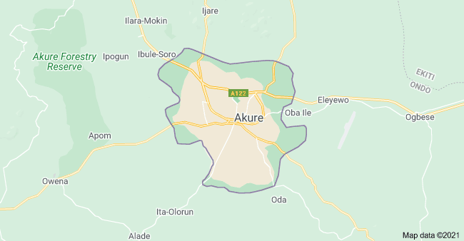

Figure 1.1: Akure metropolitan area (Source: <https://www.google.com/maps/place/Akure>)

**CHAPTER TWO**

**LITERATURE REVIEW**

**2.0 General**

This sections seeks to identify the several components of that makes of the central topic. Related studies and past researches on each component are unraveled and reviewed accordingly.

**2.1 Transportation and Transportation Systems**

The movement of people, goods, and services has become so important that it could be considered as a criteria to ensure life balance and facilitate several social and economic processes. Many authors have carefully come up with different definitions for transportation. According to David *et al.*, (2009), transportation involves the movement of people and goods from one place to another using a variety of vehicles across different infrastructure systems. This movement is achieved by harnessing not only technology (namely vehicles, energy, and infrastructure), but also people’s time and effort; producing not only the desired outputs of passenger trips and freight shipments, but also adverse outcomes such as air pollution, noise, congestion, crashes, injuries, and fatalities.

On the other hand, transportation system refers to the planning, implementation, and control of transportation services to achieve organizational goals and objectives (David, 2000). Transportation systems have become very important for social and economic development. Societies have become increasingly dependent on their transport systems to support a wide variety of activities ranging, among others, from commuting, supplying energy needs, to distributing parts between factories. According to David (No Date), a transportation system should consist of three important components;

(a) The *vehicle* (equipment) is what moves objects or *traffic* (people, goods). The vehicle consists of a container and some type of motive power, either onboard or elsewhere.

(b) The *guideway* is what the vehicles move along. The guideway consists of links and nodes that together form a network. A sequence of links is called a route. A terminal is a node where traffic is transferred from one vehicle to another.

(c) The *operations plan* is the set of procedures by which traffic and vehicles are moved over the guideway, including schedules or timetables, crew assignments, and control systems.

Merlin (1992) affirmed that, an ideal transportation system should be;

* Instantaneous
* Free
* Have unlimited capacity
* Always available

Figure 2.1 shows the different inputs, outputs and outcomes that are associated with transportation.

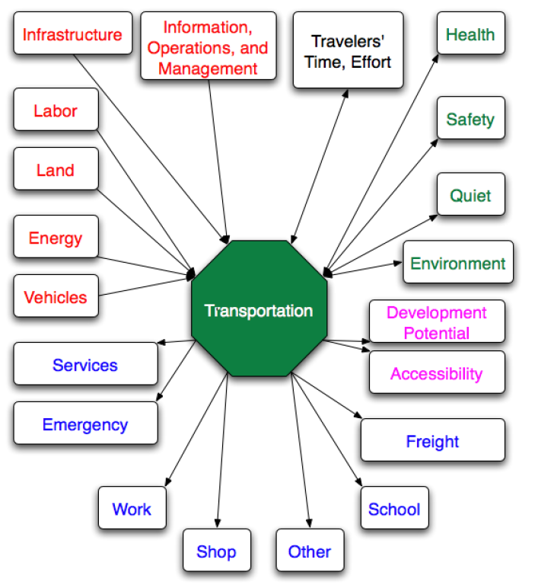

Figure 2.1: Inputs, outputs, and outcomes of transportation (David *et al.*, 2009)

**2.2 Roles/Importance of Transportation**

Effective transportation processes have proven to be a staunch facilitator of social and economic developments globally. Transportation is thus key to the continual development of developing countries.

In developed countries where there is already a well-connected transport infrastructure network of a high quality, further investment in that infrastructure will not on its own result in economic growth. However, where the potential for economic growth is present and there are capacity constraints, a lack of transport investment can inhibit potential growth (New Zealand Ministry of Transportation, 2016). In addition to the credible, viable links that transportation provides, Jean-Paul *et al.*, (2006) addressed some particular importance of transportation as;

**2.2.1 Historical**

Transport modes have played several different historical roles in the rise of civilizations (Egypt, Rome and China), in the development of societies (creation of social structures) and also in national defense (Roman Empire, American road network).

**2.2.2 Social**

Transport modes facilitate access to healthcare, welfare, and cultural or artistic events, thus performing a social service. They shape social interactions by favoring or inhibiting the mobility of people. Transportation thus supports and may even shape social structures.

**2.2.3 Political**

Governments play a critical role in transport as sources of investment and as regulators. The political role of transportation is undeniable as governments often subsidize the mobility of their populations (highways, public transit, etc.). While most transport demand relates to economic imperatives, many communication corridors have been constructed for political reasons such as national accessibility or job creation. Transport thus has an impact on nation building and national unity, but it is also a political tool.

**2.2.4 Environmental**

Despite the manifest advantages of transport, its environmental consequences are also significant. They include air and water quality, noise level and public health. All decisions relating to transport need to be evaluated taking into account the corresponding environmental costs. Transport is a dominant factor in contemporary environmental issues.

**2.3 Modes of Transportation**

Several authors have affirmed that there are four (4) basic modes of transportation. They include;

1. Road Transportation
2. Rail Transportation
3. Water Transportation
4. Air Transportation

**2.3.1 Road Transportation**

Road transport plays a main role in passenger and freight transport nowadays, especially for short and medium distances. Compared to the railways, it has an advantage of higher operability and availability; a disadvantage is a lower degree of organization in its operation, a higher negative influence on the environment, and, above all, low traffic safety.

In spite of this fact, road transport dominates in the transport market in the majority of developed countries, mainly in the freight sector. Its position is still being strengthened thanks to the building of high capacity multi-lane motorways, which create new main axes of the road network. The motorway network is then completed hierarchically with roads classified into categories which are based on their significance in terms of function and technical condition. In the developing countries, on the other hand, an insufficient road network frequently consisting of unpaved roads predominates. The construction of motorways, when considering its size and high terrain demands is demanding in terms of horizontal and vertical alignment, which results in higher land use, amount of necessary building work, as well as the total price (Dostal and Adamec, No Date).

**2.3.2 Rail Transportation**

Regarding railways we often encounter a broader term rail transport, which besides railway includes tram transport and trolleybus transport. The borderline between rail and tram transport is ambiguous in some cases, as modern transport solutions of operation in large cities prefer the interconnection of individual systems. Rail transport requires the construction of a transport route based on rails through which the locomotives and railway carriages are moved. In comparison to the road network, the railway network has a higher route deviation, which is given by the lower adhesion of vehicles. Therefore, railway is more affected by geographical conditions of landscape and has a lower ability to overcome the elevation, which brings higher financial costs in the construction of new railways. The greatest advantages of railways are its speed and the high capacity, so it has a valuable role in passenger transport mainly in high-density areas and, concerning freight transport. It is the most effective transport of mass material, like agricultural products, or raw materials, such as wood, coal, iron ore, and building materials. According to the type of the vehicle drive we differentiate between electric and motor traction. Steam engines, with the exception of some third world countries, are not in regular transport service anymore. Especially the electric traction is considered to be an environmentally friendly type of transport, thanks to its considerably lower energy consumption and lower emissions of pollutants per unit of transported cargo, in comparison to other types of transport. But the indirect consumption of the resources induced by the production of electric energy, with only a small percentage coming from renewable sources, is not negligible.

Nevertheless, the positive effects in terms of health and the environment dominate and, the renaissance of railways is expected. But it has to be adapted to the demands of modern economics and become competitive with road transport, mainly in terms of speed, punctuality, supply patterns of goods, and integration in the multimodal transport systems (Dostal and Adamec, No Date).

**2.3.3 Water Transportation**

Shipping has been used by people since time immemorial, so it is among the oldest modes of transport. It did not need a special infrastructure to be built because water forms natural transport routes, which have become the axes for the transport system in the past. Rivers and lakes were used for this purpose in inland areas and the sea in coastal zones. At the moment, shipping has an irreplaceable role in the freight transport of mass material, like iron ore, coal, or oil. In terms of passenger transport, shipping plays only an additional role nowadays; with the exception of some developing countries, it is mostly used for recreational purposes.

The nodal points of the water transport network are ports. They are large facilities established for ships to be loaded, unloaded, and where ships are taken care of. Ports tend to be connected to the land transport routes through which the goods could be further transported inland. The water infrastructure is formed by rivers, lakes, and man-made constructed canals. A lot of rivers were adjusted for the needs of water transport by canalization, which includes the straightening of the water course, construction of sluice gates, and reinforcement of banks, which bring about dramatic and irreversible changes in river ecosystems (Dostal and Adamec, No Date).

**2.3.4 Air Transportation**

The history of the youngest of the commonly used modes of transport is no longer than a century. In the interwar period the zeppelins were an important mean of transportation, but after World War II, heavier-than-air machines were victories in the battle of the use of airspace. Rapid development in air transport came at the end of the 1950s and the beginning of the 1960s.

Aviation has the main role in the fast transporting of passengers over the long-distance routes. Its role in freight transport is not generally important with the exception of hauling the mail and small parcels. The exception are remote regions of Siberia, equatorial and sub-Saharan Africa, and South America, which have a poor system of surface routes and where air transport is the basis of the transport system.

Air transport uses airspace as its transport route, mainly the stratosphere, so it is independent on the construction of overland transport routes and topographical obstacles in landscape. The only exception is the construction of network nodes - airports - which is very difficult in rough terrain. Airport construction (or expansion) is problematic in densely populated areas as well, due to difficulties to meet the required standards concerning noise. The total number of passengers transported by air is very low but thanks to the long average trip distance, it occupies approximately 10 % of the share of transportation performance worldwide. In spite of the fact that the media regularly report airplane accidents with a lot of casualties, air transport and rail transport are the safest types of passenger transport for their high degree of operating organization. As mentioned above, the air transport is not used for cargo transportation very much, so it only accounts for approximately 0.25 % of the total volume of freight transport (Dostal and Adamec, No Date).

**2.4 The Road Transport Network/System**

Bennet *et al.*, (2021) exhaustively defined and described the road transport system.

Road transport means transportation of goods and personnel from one place to the other on roads. Road is a route between two destinations, which has been either paved or worked on to enable transportation by way of motorized and non-motorized carriages. There are many advantages of road transport in comparison to other means of transport. The investment required in road transport is very less compared to other modes of transport such as railways and air transport. The cost of construction, operating cost and maintaining roads is cheaper than that of the railways (Bennet *et al.*, 2021).

Road transport can be classified as transporting either goods and materials or transporting people. The major advantage of road transport is that it can enable door-to-door delivery of goods and materials and can provide a very cost-effective means of cartage, loading and unloading. Sometimes road transport is the only way for carrying goods and people to and from rural areas which are not catered to by rail, water or air transport. Delivery of goods between cities, towns and small villages is made possible only through road transport. However, in spite of various merits, road transport has some major limitations. For instance, there are more chances of accidents and breakdowns in case of road transport. So, motor transport is not as safe as other means of transport. Road transport is also quite less organized in comparison with other modes. It is irregular and undependable. Rates for road transportation are also unstable and unequal, while the speed in road transport is slow and limited, which is a major drawback. Transporting bulky goods over long distances is also unsuitable and costly. In modern days, road transport has a serious negative impact on the environment. Building roads requires melting of tar or formulation of concrete, which may harm the associated environment. Since roads have been a major enabler of motorized transport, these vehicles also emit a lot of pollution in the form of Nitrogen dioxide, volatile organic compounds, carbon monoxide and various harmful air pollutants, including benzene, which have an adverse respiratory health effects and a serious threat to global warming. While improvisation of roads is a serious topic of research, road transport of the future includes aspects like solar panel roads and cars where solar cells have replaced asphalt or tar, and there are vehicles with electric motors reducing emission. Road transport of the future aims to work on these negativities and turn them around (Bennet *et al.*, 2021).

**2.4.1 Advantages of the Road Transport System**

Agarwal (2010) was able to outline the advantages of road transport system over the other modes of transportation.

***Less Capital Outlay***

Road transport required much less capital Investment as compared to other modes of transport such as railways and air transport. The cost of constructing, operating and maintaining roads is cheaper than that of the railways. Roads are generally constructed by the government and local authorities and only a small revenue is charged for the use of roads.

***Door to Door Service***

The outstanding advantage of road transport is that it provides door to door or warehouse to warehouse service. This reduces cartage, loading and unloading expenses.

***Service in Rural Areas***

Road transport is most suited for carrying goods and people to and from rural areas which are not served by rail, water or air transport. Exchange of goods, between large towns and small villages is made possible only through road transport.

***Flexible Service***

Road transport has a great advantage over other modes of transport for its flexible service, its routes and timings can be adjusted and changed to individual requirements without much inconvenience.

***Suitable for Short Distances***

It is more economic and quicker for carrying goods and people over short distances. Delays in transit of goods on account of intermediate loading and handling are avoided. Goods can be loaded direct into a road vehicle and transported straight to their place of destination.

***Lesser Risk of Damage in Transit***

As the intermediate loading and handling is avoided, there is lesser risk of damage, breakage etc. of the goods in transit. Thus, road transport is most suited for transporting delicate goods like chinaware and glassware, which are likely to be damaged in the process of loading and unloading.

***Saving in Packing Cost***

As compared to other modes of transport, the process of packing in motor transport is less complicated. Goods transported by motor transport require less packing or no packing in several cases.

***Rapid Speed***

If the goods are to be sent immediately or quickly, motor transport is more suited than the railways or water transport. Water transport is very slow. Also much time is wasted in booking the goods and taking delivery of the goods in case of railway and water transport.

***Less Cost***

Road transport not only requires less initial capital investment, the cost of operation and maintenance is also comparatively less. Even if the rate charged by motor transport is a little higher than that by the railways, the actual effective cost of transporting goods by motor transport is less. The actual cost is less because the motor transport saves in packing costs and the expenses of intermediate loading, unloading and handling charges.

***Private Owned Vehicles***

Another advantage of road transport is that big businessmen can afford to have their own motor vehicles and initiate their own road services to market their products without causing any delay.

***Feeder to Other Modes of Transport***

The movement of goods begins and ultimately ends by making use of roads. Road and motor transport act as a feeder to the other modes of transport such as railways, ships and airways.

**2.4.2 Disadvantages of Road Transport System**

In a similar article, Agarwal (2010) outlined the disadvantages and limitations of the road transport system.

***Seasonal Nature***

Motor transport is not as reliable as rail transport. During rainy or flood season, roads become unfit and unsafe for use.

***Accidents and Breakdowns***

There are more chances of accidents and breakdowns in case of motor transport. Thus, motor transport is not as safe as rail transport.

***Unsuitable for Long Distance and Bulky Traffic***

This mode of transport is unsuitable and costly for transporting cheap and bulky goods over long distances.

***Slow Speed***

The speed of motor transport is comparatively slow and limited.

***Lack of Organization***

The road transport is comparatively less organized. More often, it is irregular and undependable. The rates charged for transportation are also unstable and unequal.

**2.4.3 Road Transport Life Cycle**

In a recent research, Oosterhaven and Knaap (2003) examined the road transport life cycle. The impact of road transport infrastructure from the energy and environmental perspective is initially linked to the construction including associated materials and services, but the importance of whole life-cycle of a road transport infrastructure - including the use by vehicles and their own life cycle - is increasingly acknowledged in design, planning and decision processes. For example, proponents of road building may highlight the congestion relieving advantages of building additional lanes for busy routes (and the consequent theoretical reduction in energy consumption and emissions). However, considering the increased demand induced by a larger capacity, this approach may not be the most efficient option to address road transport issues due to increased GHG emissions over the life cycle of additional lanes (Oosterhaven and Knaap, 2003). Figure 2.2 shows a simplified life-cycle energy model for a road infrastructure and includes vehicles and associated maintenance.



Figure 2.2: Life-cycle energy model for road transport infrastructure (ETSAP, 2011)

**2.5 The Road Transport System in Africa**

Tchanche (2019) critically analyzed the road transport system in Africa. Having affirmed the evolution of the transport system in Africa in a previous study and explained that the transport system could be studied in three phases: the pre-colonial, the colonial, and post-colonial transport system (Tchanche, 2013). In the most recent study, he established that the road system mode of transportation in Africa have always involved several sub-modes like;

* Walk
* Animal Carriages
* Taxis
* Motor Bikes
* Buses

**2.5.1 Walking**

Walking is a common thing in developing African countries. People walk in urban areas to reach their houses, their job place, schools, hospitals, markets, etc. Although other means exist, people would prefer to move by foot. In fact, in urban areas private and public transports co-exist. Public transport is represented by taxis (known through specific colors), motorbikes (imported from Asia), minibuses, buses and other transport cars. In African megacities like Dakar, Abidjan, Lagos, Accra, Cotonou, and Douala, more than 70% of population use their feet for short distances. The choice of the walk as main mean of mobility is justified by the low purchasing power of the population and low development level of infrastructures. Walk requires a minimum number of conditions to be met. First shoes wore should be well adapted to the foot and to the type of road and weather. Second, dedicated space should be made available. Walking implies muscular effort for the walker which translates into skin transpiration. Walk exposes to random atmospheric conditions, insolation, wind, dust, rain and even tornado in some cases (Tchanche, 2019).

Walkers in urban areas do compete with cars on streets. On pavements, due to the small width walkers are forced to leave more often and confront the lane dedicated to the motorized vehicles. In some places, pavements disappear when some sellers use roads as marketplace pushing the walkers to walk on forbidden zones and putting their lives at risk. Crossing roads can be a very difficult exercise. Traffic lights are not common on most roads and where they are present they are rarely functioning because of lack of maintenance or not respected when they are in good conditions. Pedestrians then put their life at risk, while crossing or will spend a lot of time waiting for a kind driver to stop and allow them to cross. Because of the high speed and frequent accidents, authorities find useful to install “speed bumps”, often poorly designed to force the drivers to slow the speed and in some areas, they install a bridge to allow pedestrians to cross safely. However, they are not always adapted for people with disabilities and some of these underground bridges, are transformed into traps during nights and people will be reported attacked by armed robbers (Tchanche, 2019).

Rural areas usually receive less investments for infrastructure development. Roads are more often in poor condition, unpaved and limited to tracks that allow people to visit their neighbors or relatives and to move to farms. This situation hampers the development of these areas which present very few opportunities, and the peasants cannot transport safely and efficiently agricultural products on the markets and thus most of their harvest is wasted. Health care facilities are usually far from the village and people will move to the nearest city, and this does not allow patients to be transferred easily and safely (Tchanche, 2019).

**2.5.2 Animal Carriages**

Animal carriage is a mode of transport that involves animals pulling a mechanical structure. Animals often chosen are cows, donkeys and horses. Usually, we have one or more animals in front of a tray mounted on two wheels. They serve in rural areas and in urban areas as well, for the transport of people and goods. They are very popular in some countries and offer some advantages: affordability and flexibility. The average price for a trip is usually low, affordable for populations with low revenues. They easily adapt to unpaved roads and can stop almost everywhere to carry and debark passengers. Their speed is higher than that of a walker but very low compared to motorized systems. The carriages are usually locally manufactured by self-taught craftsmen, and the manufacturing time around three months. For owners, it constitutes an important source of income. Animals must be fed and well maintained. This transport means although popular has not attracted a lot of attention and needs to be examined. The identification of carriages is not always addressed. Dedicated lanes are not developed and they hamper the movement of motorists. The signaling systems do not exist as well as the lighting system (Tchanche, 2019).

**2.5.3 Taxi Bikes**

Motorcycles are first used as private means of transport, and are characterized by their limited number of places, normally two the most. These engines have gradually been transformed into a means of public transport in the recent history of Africa. They are known with different names. They display many advantages: low investment cost, low operating cost, service affordability and flexibility. Usually, the driver takes a passenger with reduced luggage. It is very useful on tracks and areas not reachable by cars. These motorcycles are imported from Asia and especially China for their low cost of about US$ 600. In many countries where unemployment rate is relatively high among youth, it is considered as a fulltime job (Tchanche, 2019).

**2.5.4 Taxi Cabs**

Taxis in African cities are five seats vehicles painted with specific colour: yellow, green, mix of yellow and black, etc. Depending on countries or cities the driver could carry one or several passengers for one or several directions. The cost of the trip is either adopted by the government or negotiated with the passenger. A taxi may have a specific area or could move in the entire city. In many countries, drivers and owners use to organize themselves in unions to defend their interest. They need a license and regularly pay insurance and other taxes related to their activity (Tchanche, 2019).

**2.5.5 Buses and Minibuses**

Minibuses have appeared in most megacities to complement the limited offer of taxis and buses. They generally serve the popular neighborhoods located on the outskirts of the city. They operate on specific destinations, linking sub-urban areas with the centre of the city. They are known with various names: trotro (Ghana), ndiaga ndiaye or car rapid (Senegal), Gbaka (Ivory Coast), etc. Usually, drivers and owners have a specific station and organize themselves in trade unions. Like for taxis, owners acquire a license and pay relevant taxes. Cars used as minibuses are imported from other continents, then modified to increase the number of seats and maximize profitability. Two individuals, the driver and his assistant manage the vehicle. One drives while the other takes care of boarding the passengers. Intra-urban bus transport is an endeavor with more or less experience in African cities. In an effort to organize urban transport, some governments established public transport companies: Dakar Dem Dik (Senegal), Sotra (Ivory Coast), Stecy (Cameroon), etc. They are managed by two individuals, the driver and the ticket vendor. The routes are well determined but the stopping points are not always visible and clearly identified. Maps of the route are quite rare or do not exist (Tchanche, 2019).

**2.6 Factors Responsible for Road Transport Accidents**

Many scholarly researches and articles have ensued on the study of the causes and factors responsible for road transport accidents globally.

Malik (2017) in his study of the causes, rate and prevention of road transport accidents, established the factors that are primarily responsible for road transport accidents.

***Road Users***

Excessive speed and rash driving, violation of traffic rules, failure to perceive traffic situation or sign or signal in adequate time, carelessness, fatigue, alcohol, sleep etc.

***Vehicle***

Defects such as failure of brakes, steering system, tire burst, lighting system, etc.

***Road Condition***

Skidding road surface, pot holes, ruts, etc.

***Road design***

Defective geometric design like inadequate sight distance, inadequate width of shoulders, improper curve design, improper traffic control devices and improper lighting,.

***Environmental factors***

Unfavorable weather conditions like mist, snow, smoke and heavy rainfall which restrict normal visibility and makes driving unsafe.

***Other causes***

Improper location of advertisement boards, gate of level crossing not closed when required etc.

Figure 2.3 also shows a statistical result from the study on the most prone motor vehicles to road transport accidents.

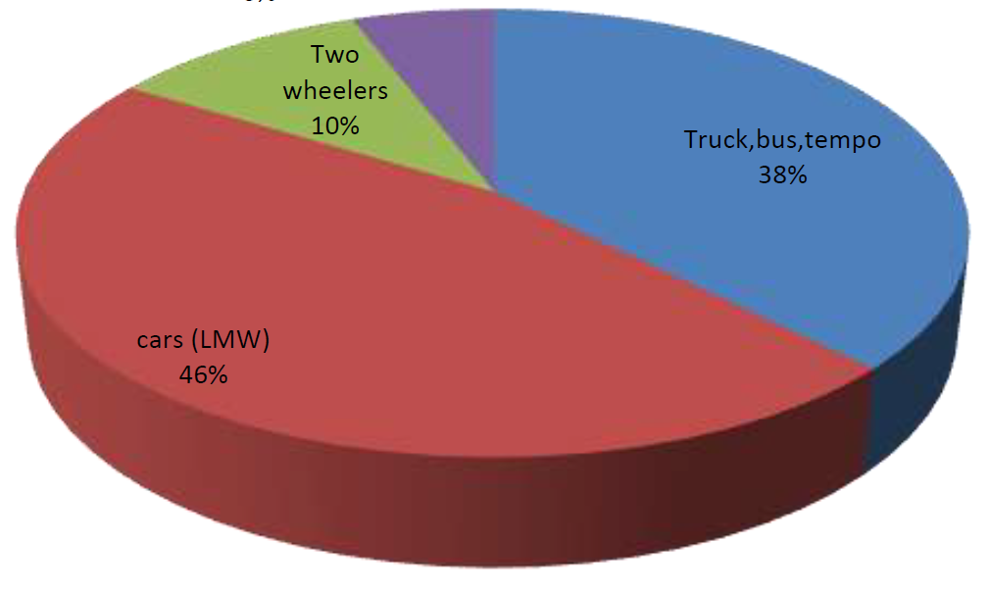

Figure 2.3: Percent share of moto vehicles in road transport accidents (Malik, 2017)

According to the Federal Road Safety Corps of Nigeria, road accidents in Nigeria are induced by over-loading, unnecessary speeding, wrongful overtaking, lack of proper judgment from drivers, lack of adequate experience, carelessness, machine failure, recklessness, intoxication, tedium, lack of willingness to alight from motion objects (human beings, motor cycles, uncontrolled animals and vehicles), dazzling and defective light, skid and road surface defect, obstruction and improper use of level crossing. Other causes include seat belt misuse, use of mobile phones when driving, and corruption from inadequate application of traffic laws (FRSC, 2010).

In another study by Oluwaseyi and Gbadamosi (2017), they attributed road traffic accidents to drivers’ errors which include unruliness, over speeding, inappropriate overtaking, lack of attention, inexperience, carelessness and intoxication. Furthermore, according to him nearly six percent were from mechanical vehicular factors while another six percent was due to road construction problems. As for mechanical causes, the incidence is traced to owners’ or drivers’ refusal to practice expected maintenance checks on their vehicles until they degenerate into disastrous conditions.

Muhammad and Peter (2016) particularly studied the factors responsible for road transport accidents along the Kano-Kaduna-Abuja dual carriageway in Nigeria. The study established that lack of routine repairs, maintenance and the existence of potholes are responsible for crashes on the highway. It was recommended that the relevant ministry and its agencies should always effect repairs on bad portions of the highways. More so, driver’s education and sensitization should always be strengthened and enforced to ensure compliance for proper driving habits.

**2.7 Consequences of Road Transport Accidents**

Many scholars and researchers have placed great importance on the study of the consequences of road transport accidents, particularly to quantify the level of losses accrued to these dreadful occurrences.

Richard and Bridget (2002) carefully studied the consequences and effects of road transport accidents on different users of the road. The study encompassed the physical, social, and psychological consequences on the users. The study summarized the effects of road transport accidents on the users as;

***Pedestrians***

They were older than other groups, suffered more severe injuries, were more likely to be admitted and to undergo surgery and they spent longer in hospital. A greater proportion of pedestrians (14%) were specifically noted as showing evidence of intoxication compared with 5% of drivers, 3% of passengers, 2% of motorcyclists and 2% of cyclists.

***Cyclists***

They were younger than other groups, suffered less severe injury and their injuries were particularly likely to be head, face, arm and leg injuries. A minority were known to be wearing helmets.

***Motorcyclists***

They were males, were more likely to have a manual occupation and to have suffered previous road traffic accidents. They were more likely than other groups (other than pedestrians) to have suffered severe injuries, particularly of the arm/leg and were especially likely to have suffered multiple injuries to several body regions. They were more commonly admitted than other groups.

***Vehicle drivers***

They were more likely to have been taken to hospital by ambulance and commonly reported neck, chest and leg injuries. A minority had suffered no recordable injury.

***Vehicle passengers***

They were mainly female, were usually taken to hospital by ambulance and were particularly likely to report neck, chest and leg injuries. A minority had no recordable injury. They were more likely than other groups to be frightened by the accident and they were less likely to see themselves as having been to blame.

The study also showed the reactions of these set of users to respective road traffic accidents. Results are shown in the chart below.



Figure 2.4: Reactions of users to road traffic accidents (Richard and Bridget, 2002)

Also, Gbadamosi (2015) laudably studied the consequences of road transport accidents in Nigeria. The study stemmed from the population explosion and increased motorization that have resulted into fatal road accidents, causing death of adolescents and youths in Nigeria at an alarming rate. The study drew conclusions from the effect of road traffic accidents statistics in Nigeria. Table 2.1 below shows statistics of casualties recorded from road accidents in Nigeria between 1990 and 2012.

Table 2.1: Road Traffic Accidents statistics from 1990 to 2012 (Gbadamosi, 2015)

|  |  |  |  |  |  |  |  |
| --- | --- | --- | --- | --- | --- | --- | --- |
| **Years** | **Road Traffic Accidents** | | | **Total** | **Casualty** | | **Total** |
|  | **Fatal** | **Serious** | **Minor** |  | **Killed** | **Injured** |  |
| 1990 | 6140 | 8796 | 6998 | 21934 | 8154 | 22786 | 30940 |
| 1991 | 6719 | 8982 | 6845 | 22546 | 9525 | 24508 | 34033 |
| 1992 | 6986 | 9324 | 6554 | 22864 | 9620 | 25759 | 35379 |
| 1993 | 6735 | 8443 | 6281 | 21459 | 9454 | 24146 | 33600 |
| 1994 | 5407 | 7522 | 5275 | 18204 | 7440 | 17938 | 25378 |
| 1995 | 4701 | 7276 | 5053 | 17030 | 6647 | 14561 | 21208 |
| 1996 | 4790 | 6964 | 6488 | 18242 | 6364 | 15290 | 21654 |
| 1997 | 4800 | 7701 | 4987 | 17488 | 6500 | 10786 | 17286 |
| 1998 | 4757 | 7081 | 4300 | 16138 | 6538 | 17341 | 23879 |
| 1999 | 4621 | 6888 | 4356 | 15865 | 6795 | 17728 | 24523 |
| 2000 | 5287 | 6820 | 4499 | 16606 | 8473 | 20677 | 29150 |
| 2001 | 6966 | 8185 | 5379 | 20530 | 9946 | 23249 | 33195 |
| 2002 | 4029 | 7190 | 3325 | 14544 | 7407 | 22112 | 29519 |
| 2003 | 3910 | 7882 | 2572 | 14364 | 6452 | 18116 | 24568 |
| 2004 | 3275 | 6949 | 4051 | 14275 | 5351 | 16897 | 22249 |
| 2005 | 2299 | 4143 | 2620 | 9062 | 4519 | 15779 | 20298 |
| 2006 | 2600 | 5550 | 964 | 9114 | 4944 | 17390 | 22334 |
| 2007 | 2162 | 4812 | 1503 | 8477 | 4673 | 17794 | 22467 |
| 2008 | 3024 | 5671 | 2646 | 11341 | 6661 | 27980 | 34641 |
| 2009 | 2460 | 6024 | 2370 | 10854 | 5693 | 27270 | 32963 |
| 2010 | 1178 | 2819 | 1333 | 5330 | 4065 | 18095 | 22160 |
| 2011 | 1764 | 2485 | 516 | 4765 | 4372 | 17464 | 21836 |
| 2012 | 1953 | 3106 | 1210 | 6269 | 4260 | 20757 | 25017 |
| **TOTAL** | **96563** | **150613** | **90125** | **337301** | **153853** | **454423** | **608277** |

Further in the study, it was established that the consequences of road transport accidents range from the physical, social, and economic impact it has on man to the economic impacts it has on the national economy and the impact it has on the vehicle itself. Road transport has had a modest contribution to the Gross Domestic Product of the economy over the years. It normally accounts for not less than 80% of the portion to the GDP emanating from the transport sector as a whole.

Road accidents also sometimes lead to destruction of traffic infrastructure such as bridges thereby destroying publicly provided transport infrastructure. Road traffic accidents have also negatively affected Manpower resource of the country (Afolabi and Gbadamosi, 2017).

**2.8 Artificial Neural Network**

A neural network is an interconnected assembly of simple processing elements, units or nodes, whose functionality is loosely based on the animal neuron. The processing ability of the network is stored in the interunit connection strengths, or weights, obtained by a process of adaptation to, or learning from, a set of training patterns (Gurney, 1997).

Biologically, Neurons communicate via electrical signals that are short-lived impulses or "spikes" in the voltage of the cell wall or *membrane.* The interneuron connections are mediated by electrochemical junctions called *synapses,* which are located on branches of the cell referred to as *dendrites*. Each neuron typically receives many thousands of connections from other neurons and is therefore constantly receiving a multitude of incoming signals, which eventually reach the cell body. Here, they are integrated or summed together in some way and, roughly speaking, if the resulting signal exceeds some threshold then the neuron will "fire" or generate a voltage impulse in response. This is thentransmitted to other neurons via a branching fibre known as the *axon* (Gurney, 1997).

In determining whether an impulse should be produced or not, some incoming signals produce an inhibitory effect and tend to prevent firing, while others are excitatory and promote impulse generation. The distinctive processing ability of each neuron is then supposed to reside in the type—excitatory or inhibitory—and strength of its synaptic connections with other neurons.

It is this architecture and style of processing that we hope to incorporate in neural networks and, because of the emphasis on the importance of the interneuron connections, this type of system is sometimes referred to as being *connectionist* and the study of this general approach as *connectionism*. This terminology is often the one encountered for neural networks in the context of psychologically inspired models of human cognitive function. However, we will use it quite generally to refer to neural networks without reference to any particular field of application (Gurney, 1997).

The artificial equivalents of biological neurons are the nodes or units in our preliminary definition and a prototypical example is shown in Figure 2.5. Synapses are modelled by a single number or *weight* so that each input is multiplied by a weight before being sent to the equivalent of the cell body. Here, the weighted signals are summed together by simple arithmetic addition to supply a node *activation*. In the type of node shown in Figure 2.5 — the so-called *threshold logic* *unit* (TLU) — the activation is then compared with a threshold; if the activation exceeds the threshold, the unit produces a high-valued output (conventionally "1"), otherwise it outputs zero (Gurney, 1997).

The term "network" will be used to refer to any system of artificial neurons. This may range from something as simple as a single node to a large collection of nodes in which each one is connected to every other node in the net. One type of network is shown in Figure 2.6. Each node is now shown by only a circle but weights are implicit on all connections. The nodes are arranged in a layered structure in which each signal emanates from an input and passes via two nodes before reaching an output beyond which it is no longer transformed. This *feedforward* structure is only one of several available and is typically used to place an input pattern into one of several classes according to the resulting pattern of outputs. For example, if the input consists of an encoding of the patterns of light and dark in an image of handwritten letters, the output layer (topmost in the figure) may contain 26 nodes— one for each letter of the alphabet—to flag which letter class the input character is from. This would be done by allocating one output node per class and requiring that only one such node fires whenever a pattern of the corresponding class is supplied at the input (Gurney, 1997).



Figure 2.5: An artificial neural network (Gurney, 1997)



Figure 2.6: A simple neural network (Gurney, 1997)

**CHAPTER THREE**

**MATERIALS AND METHODOLOGY**

**3.0 Materials**

The major materials that were instrumental to achieving the objectives of this research were the secondary data sources and records from the Federal Road Safety Corps (FRSC), and the Artificial Neural Network models for predictions. Figure 3.1 below represents a flowchart of the major methods and processes that were taken, in chronological order to achieve the aim of this research.

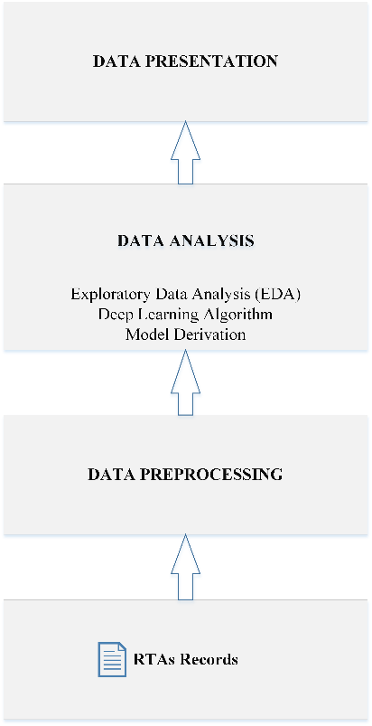

Figure 3.1: Flowchart for Road Traffic Accidents Analysis in Akure, Nigeria

**3.1 Procurement of Road Traffic Accidents Data**

The data employed for this research work was collected from the Federal Road Safety Corps (FRSC), RS11.2, Ondo Sector. Each row of data contains information about every accident case recorded from the various unit commands in the state (RS11.21, RS11.22, RS11.23, RS11.24, and RS11.25) and the sector command: RS11.2, between 2016 and 2020. Each row of the Road Traffic Accidents (RTAs) table has the following attributes: ( 'accident_id', 'unit_command_id', 'date', 'crash_time', 'report_time', 'arrival_time', 'response_time', 'route', 'location', 'vehicle_no', 'vehicle_type', 'vehicle_category', 'vehicle_make','vehicle_model','fleet_operator','name_of_driver','dl_no','causes','number_of_injured_male_adult','number_of_injured_female_adult','number_of_injured_male_child','number_of_injured_female_child','total_injured','number_of_killed_male_adult','number_of_killed_female_adult','no_killed_male_child','number_of_killed_female_child','total_killed','number_of_involved_male_adult','no_involved_female_adult','no_involved_male_child','no_involved_female_child','total_involved'. The collected data is not cleaned properly and contains a lot of missing fields. However, of great importance was the “causes” of the Road Transport Accidents, and as such was represented as shown in Figure 3.2.

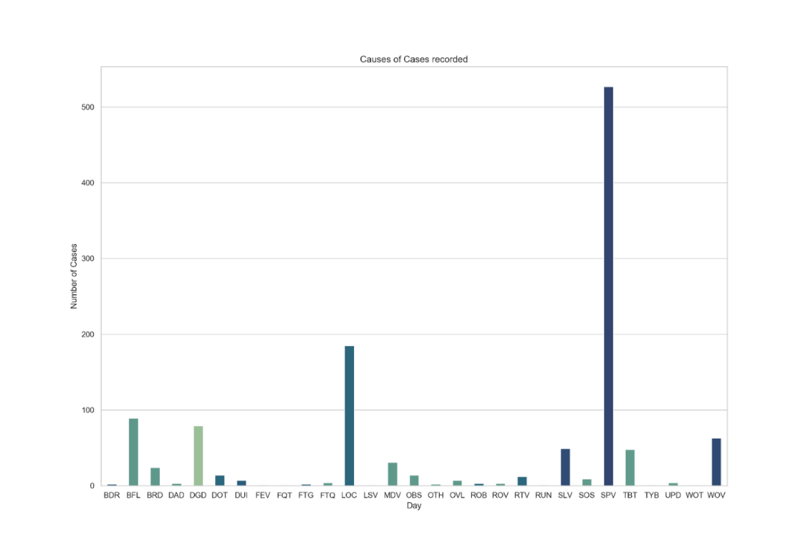

Figure 3.2: Causes of accident data distribution

* 1. **Preprocessing of Road Traffic Accidents Data**

Data Preprocessing involves the preparation of the raw data collected for analysis. The data collected consists of 911 accident cases distributed for each year in this order: 2016 – 37 data points, 2017 – 222 data points, 2018 – 258 data points, 2019 – 215 data points, 2020 – 179 data points. The data collected for 2016 is small compared to others as it contains only information for two (2) months. Among the total set were some missing data, in order to mitigate for this, data points without information regarding the: crash time, report time and arrival time were removed completely. This reduced the data points to 874. Also, four (4) data points have the ‘date’ feature missing, this is however a very sensitive feature. Rather than remove this row completely, the missing dates were backfilled using the date succeeding the missing row.

There were inconsistencies in the format of the 33 features found in the data, some features are expected to maintain a standard format such as the number of person involved (numeric), the number of fatal cases(numeric), vehicle type (string). Rather, the order was random. However, for the purpose of smooth analysis, each feature needs to maintain consistent representation across the dataset. Hence, the data was cleaned properly.

**3.2.1 Data Transformation**

Data transformation involves the transformation of the raw data into some set of new attributes. Highly significant features such as the total number of automobiles involved, the month, and the day of week were not included in the 33 features provided. To mitigate for this, some features were transformed from the 33 features intelligently.

**3.2.2 Data Splitting**

Having cleaned the total set from noise, it is important to split the data before subjecting it to feature engineering, so as to prevent data leakage. Splitting using random sampling has the tendency to introduce bias considering the intrinsic nature of the dataset as shown in figure 3.6. Hence, the stratified sampling was adopted, this will ensure every class of the label is well represented in the training set and the test set. Stratified sampling does this by dividing the total population into homogenous subgroups called strata after which the right number of instances is sampled from each stratum to guarantee that the test set is representative of the overall population. The data was split into two set after on 80:20 ratio, for the training set and test set respectively.

**3.2.3 Feature Engineering**

Only relevant features from the 33 attributes in the total data record will be useful in the training of the model. Hence, it is important to select the relevant features from the attributes and also extract new features from the relevant ones.

**3.2.4 Feature Selection**

However, before embarking on, some attributes were removed completely. The 'fleet_operator','name_of_driver','dl_no’ which represent the name of fleet operator, the name of driver, the vehicle registration number have over 98% of the total records missing. Hence, their removal from the total set. Furthermore, other features removed include “location” and “vehicle_no”.

**3.2.5 Normalization**

Machine Learning models are very sensitive to numeric values. Hence, it is imperative to scale continuous values in every column to a specific range (i.e., normalization). The ‘MinMaxScalar’ library provided by scikit learn was adopted. 'report_minus_crash','arrival_minus_crash','arrival_minus_report' were normalized using this method. The formula guiding this is expressed in equation 1

(1)

**3.2.6 Feature Extraction**

In addition, the following features ‘report_minus_crash’, ‘arrival_minus_crash’, ‘arrival_minus_report’ were extracted from the ‘crash_time’,’ report_time’, ‘arrival_time’, and ‘response_time’ attributes via arithmetic operations.

1. ‘report_minus_crash’ - Number of seconds between the crash time and report time
2. ‘arrival_minus_crash’ - Number of seconds between the crash time and arrival time
3. ‘arrival_minus_report’ - Number of seconds between the arrival time and crash time

Having done this, the ‘report_time’, ‘arrival_time’, and ‘response_time’ were dropped from the features. Also, the ‘crash_time’ recorded in ‘date_time’ format was replaced with the hour the crash occurs. These were done in the bid to further make the attributes usable.

In addition, machine learning algorithms cannot work with categorical data directly. Hence, categorical data must be converted to binary vectors. This was implemented for the feature: ‘route’ and also for the label:’causes’ using the One-Hot Encoding. The tool first converts categorical data integer values before representing each value with binary vectors. Furthermore, computations cannot be done texts which are found in some significant attributes such as 'vehicle_type' and 'vehicle_category'. It is therefore also important that features are extracted intelligently from these attributes.

**3.2.7 Natural Language Processing (NLP)**

The following features: ‘location’, ‘vehicle_no’, ‘vehicle_type’, ‘vehicle_cat’, ‘vehicle_make’, ‘vehicle_model’ represented in text format are going to be significant to the learning algorithm. Hence, features need to be extracted from them intelligently. Hence, the concept of Natural Language Processing (NLP) was employed. NLP helps to analyze, understand, and derive meaning from human language in a smart and useful way. Instead of coding rules to derive features NLP algorithms learn by analyzing examples found in the dataset. In order to actualize this. An open-source library called Natural Language Toolkit (NLTK) was used, it contains text processing libraries used for language processing tasks such as tokenization, parsing, classification, stemming, tagging and semantic reasoning.

**Tokenization:** The texts in the mentioned columns are unstructured. For the texts to be useful, they need to be represented in discrete elements. Hence, Tokenization. It involves the representation of unstructured string with discrete elements.

**“Stopwords”:** Having discretized the words in each row, there is possibility of having “stopwords” such as ‘a’, ‘and’, ‘of’ and many more in the tokens. Hence, the need for filtering. No “stopwords” were found on subjecting the text in the six (6) columns to the list of “stopwords” obtained from NLTK corpus library.

**Stemming:** In order to avoid repetitions, the filtered tokens are subjected set of rules that will represent similar words with a unique text.

The Bag of Words (BOW) model was adopted for features extraction. It involves converting text-data to numerical vectors (vectorization) as features. Hence, the tokens are converted into numerical vectors. Vectorization can be done either by counting number of times each word appears or calculating the frequency that each word in each row out of all the words in the column. The former results to a sparse matrix which requires a lot of memory and computational resources. Hence, the latter method is widely adopted.

**Term Frequency-Inverse Document Frequency (TF-IDF) Algorithm**

The library term frequency-inverse document frequency (TF-IDF) vectorizer was adopted for the work. TF-IDF measures how important a word is to a word collection. This is actualized by multiplying the Term Frequency **(**TF) and Inverse Document Frequency (IDF).

**Term Frequency (TF)**: It is a scoring of the frequency of the word in the total word collection. Since every sentence row is differs in length, it is possible that a word would appear much more times in long documents than shorter ones. Hence, TF is expressed as:

**Inverse Document Frequency (IDF)**: This metric measure how rare a word is among other words in the column.

**3.3 Conceptual Framework of Artificial Neural Network**

Artificial Neural Network (ANNs) are software implementations of the neuronal structure of a human brain. The neural network of the brain consists of hugely interconnected neurons. The output of a given neuron may be the input to thousands of neurons. Learning is inferred from the connections and feedbacks among the neurons. ANN tends to mimic the brain, the networks among the neurons are represented as connected layers of nodes. Each node takes real valued multiple weight inputs from other nodes or data inputs. The summation of these inputs is subjected to an activation function that determines the output. However, the weight values are updated during the learning process.

A stream of inputs, a node and output make a perceptron (Figure 3.3) according the literature. ANN can be supervised or unsupervised. In the supervised ANN, the network is trained with a given set of inputs and output data points. Hence, a typical simple neural network consists of an input layer, a hidden layer and an output layer as illustrated in Figure 3.4 shown below, each connection has an associated weight. The learning of the pattern in the data takes place by adjusting the weights of the connections. The hidden layer may extend beyond one (1), depending on the complexity of the network.

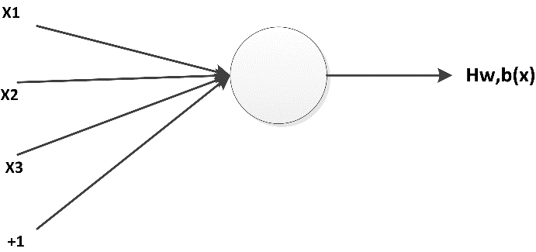

Figure 3.3: A perceptron

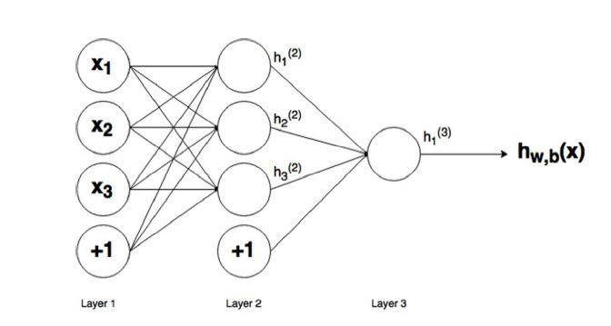

Figure 3.4: A full-fledged simple neural network

**3.3.1 Feed-Forward Pass**

The process of calculating the output of a neural network is called feed forward propagation. This is done using the components explained i.e., the inputs, weights, bias, and the activation function. For instance, the neural network output in Figure 3.4 is evaluated using the equation 2 shown below. The weights are multiplied with inputs and summed with the bias before being subjected to activation function. The output of each node is fed to the next layer for the same process.

begin mathsize 20px style h subscript 1 open parentheses 2 close parentheses space equals space f. open parentheses w subscript 11 open parentheses 1 close parentheses space x subscript 1 plus space w subscript 12 open parentheses 1 close parentheses space x subscript 2 space plus w subscript 13 open parentheses 1 close parentheses space x subscript 3 space plus b subscript 1 open parentheses 1 close parentheses close parentheses
h subscript 2 open parentheses 2 close parentheses space equals f. open parentheses w subscript 21 open parentheses 1 close parentheses space x subscript 1 plus space w subscript 22 open parentheses 1 close parentheses space x subscript 2 space plus w subscript 23 open parentheses 1 close parentheses space x subscript 3 space plus b subscript 2 open parentheses 1 close parentheses close parentheses space
h subscript 3 open parentheses 2 close parentheses space equals space f. open parentheses w subscript 31 open parentheses 1 close parentheses space x subscript 1 plus space w subscript 32 open parentheses 1 close parentheses space x subscript 2 space plus w subscript 33 open parentheses 1 close parentheses space x subscript 3 space plus b subscript 3 open parentheses 1 close parentheses close parentheses

h subscript w comma b end subscript open parentheses x close parentheses space equals space h subscript 1 open parentheses 3 close parentheses space equals space f. open parentheses w subscript 11 open parentheses 2 close parentheses h subscript 1 open parentheses 2 close parentheses plus space w subscript 12 open parentheses 2 close parentheses h subscript 2 open parentheses 2 close parentheses space plus space w subscript 13 open parentheses 2 close parentheses h subscript 3 open parentheses 2 close parentheses close parentheses
end style (2)

Where f (.) = node activation function

= the input weight to node I in layer (l+1) from layer l.

e.g., = input weight of node 1 in layer 3

= output of node i in layer l.

e.g., = output of node 2 in layer 1

**3.3.2 Gradient Descent and Optimization**

The idea of updating the weights (the learning process) is to minimize the error between the inputs and the desired output. Hence, the concept behind supervised learning is to provide many input-output pairs of known data and vary the values of weights using the supplied samples, such that the error expression is reduced. It is important to note that these samples are not single valued, each can be a vector as in the case of this work, where each sample has about 33 features (33*1).

Having established that the weights need to be varied using the input-output pair supplied, the concept of gradient descents provides the know-how of how to vary the weight.

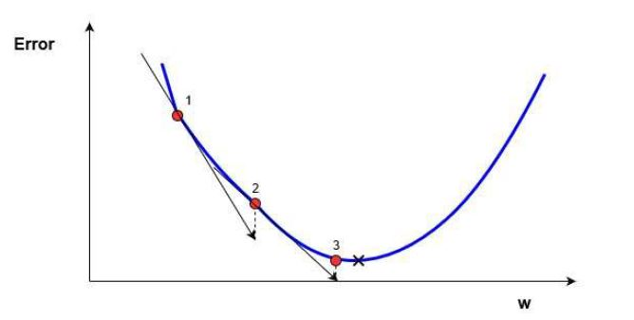

Figure 3.5 One dimensional gradient descent

From Figure 3.5, the error is best minimized at point 3. However, it is important to note that on commencing, the initial value of the weight is selected random but the value is gradually and intelligently adjusted until it gets to a point as 3 (which is the minimum possible error). This is done by evaluating the gradient at each output obtained from each sample (which the error). If the gradient obtained from an increased weight (w) yields a positive value, a further step in that direction (increase) will further lead to error. If it is negative, a further step in that direction will lead to a decrease in error. As a way to minimize the error, the value of w is then adjusted using this concept. The steepness of the slope as illustrated in figure 3.3 shows how fast the error is changing – ***learning rate (*.** This iteration continues as new value of w is obtained using equation 4. As the solution approaches the minimum error, the gradient flattens out and the iteration stops.

begin mathsize 18px style w subscript o l d end subscript space equals space w subscript n e w end subscript space minus alpha times space g r a d i e n t end style 3

In order to prevent over-fitting, the error (cost function) is usually not evaluated by finding the difference between the expected output and the obtained value. Rather, for a single training pair (xz, yz) the cost function can be obtained as the Sum of Squares Error (SSE) expressed in equation 4 or any other expressions. Hence, equation 3 can be rewritten as equation 5.

4

5

**3.4 Building the Artificial Neural Network (ANN)**

The objective of this phase is to establish the relationship between the features supplied and the causes of accident. In the context of regression problem to be solved, a multilayer perceptron will be adopted. This helps us to solve problems that are not linearly separable via the concept of multiple layers. This work will thus predict the cause of any accident instance given.

**Input Layer**: This layer consists of neurons that introduces the input patterns into the network. Having extracted features from the text attributes, the addition with the numerical features results in 1118 columns. No processing takes place at these neurons. These neurons are connected with a ‘ReLU (rectified linear unit) activation

**Hidden Layers**: These are those neurons whose inputs come from earlier layers and the outputs pass to the neurons in subsequent layers, two (2) hidden layers were employed arrived at the optimal accuracy obtained, each having 128 neurons each. Also, the ReLU activation was also employed on every layer.

**Output Layers:** There is only one layer here, with 29 neurons as we have all the possible causes encoded using one-hot encoding. The output is connected to a softmax function which is used for multiclass classification. The softmax function is expressed as:

6

When calculating the value of softmax on a single raw output (e.g., z1), we can’t just look at z1 alone: we have to take into account z1, z2, z3, and z4 in the denominator.

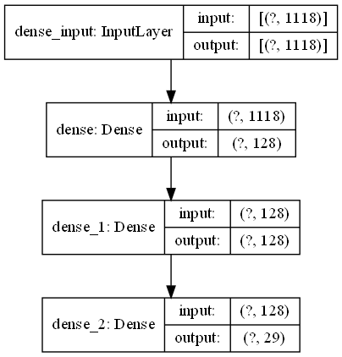

Figure 3.6: Multilayer Perceptron adopted

The Keras library was employed for the building the neural network. It provides the Sequential method from the keras.models and the Dense function from the keras.layers library. The Sequential method helps to build the layers of the ANN. The following parameters were set:

**Units:** This defines the number of nodes in a particular layer. As illustrated in figure 3.4, the 3 hidden layers has 128 nodes. Hence, the units were set to 128.

**Kernel_Initializer:** The weights to each node need to be initialized. This parameter is used to set the starting values for the weight. ‘uniform’ was defined in the first four (4) layers; this initialized the weights values from a uniform distribution.

**Activation:** The activation function for the neurons in each layer is set using this parameter. In all the layers, the ReLU function was adopted.

**Input_dim:** This defines the number of inputs to the input layer; this number is equal to the number of columns of the input set. This parameter is only required in the first input layer.

**Optimizer:** This is chosen to be ‘adam’, it is an extension of the stochastic gradient descent. It not only considers the gradient of the current step, but also accumulates the gradients of previous steps.

The above hyper-parameters were selected after comparing the results obtained from varying the optimizer, loss function and activation function.

**CHAPTER FOUR**

**RESULTS AND DISCUSSION**

**4.0 Exploratory Data Analysis**

Exploratory Data Analysis involves the analysis of a dataset in the bid to summarize the characteristics using statistical tools and visualization techniques. Figure 4.1 shows the number of RTA total cases recorded each month between 2016 and 2020 in Ondo state.

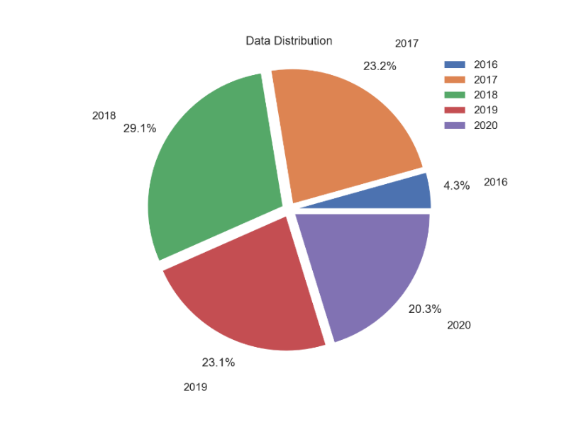

Figure 4.1: Data Distribution on a yearly basis

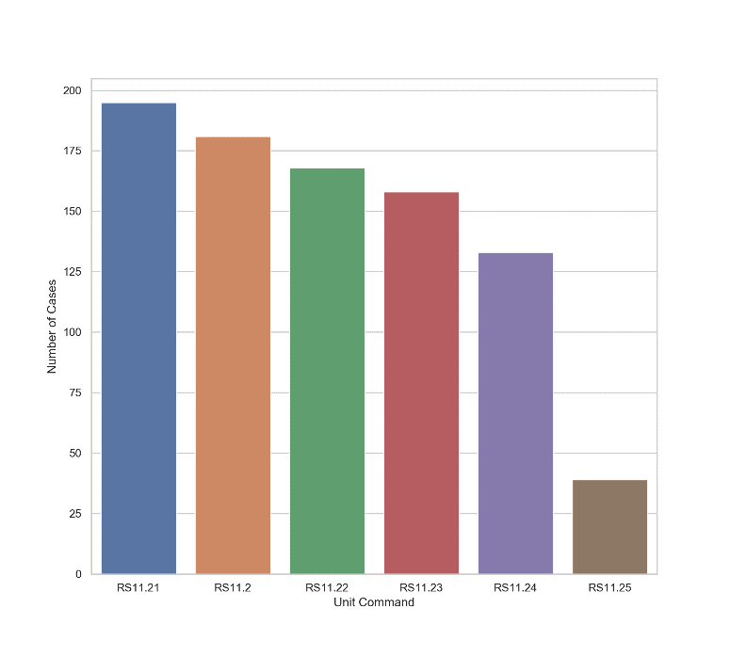

Figure 4.2: Data Distribution based on Unit Command

The visualization shown in Figure 4.3 indicates August to be the month with the highest number of cases, followed by June, February, May and December. The Figure 4.4 also indicates the number of persons involved and the number of lives lost on a monthly basis, the figure shows that several fatal cases were recorded most in May, December and August. December appearing on both figures can infer a lot of automobiles on the road as such period.

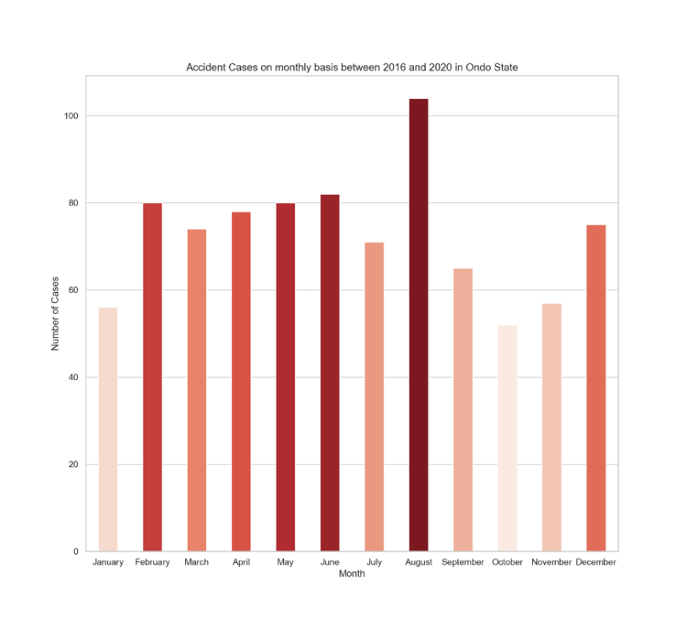

Figure 4.3: Accident Cases recorded each month

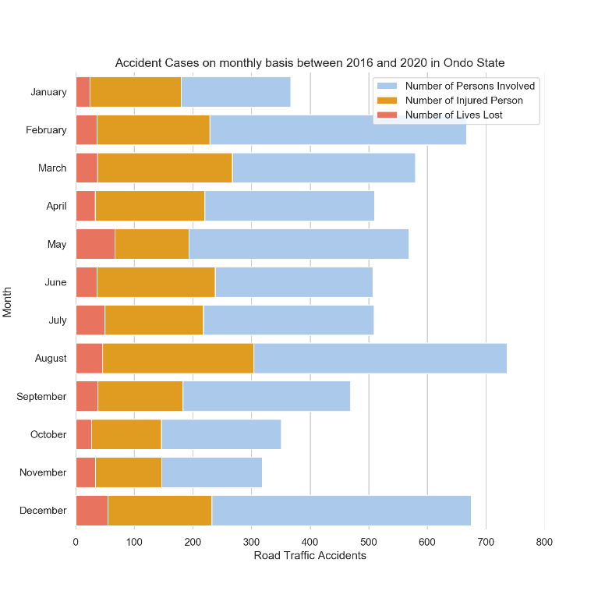

Figure 4.4: Accident Cases showing the number of persons involved and lives lost

**4.1 Data Analysis**

In relation to this work, the further analysis was carried out on the data acquired:

1. Analysis based on time
2. Analysis based on routes/location

**4.1.1 Analysis based on time**

The Figure 4.5 and Figure 4.6 show the accident cases every 3-hour and 6-hour respectively. The ‘sn’ column represents that number of cases recorded. The tables shows that the most RTAs are recorded in daytime, between the 6th hour and 18th hour. Also, the table indicates that most fatal cases are recorded during the mentioned period. However, cases recorded at midnight are very minimal when compared with other periods of each day. In addition, from the data collected one can infer from Figure 4.7 that RTAs occur mostly on weekends, with the least cases recorded on Thursdays and the most on Sundays.

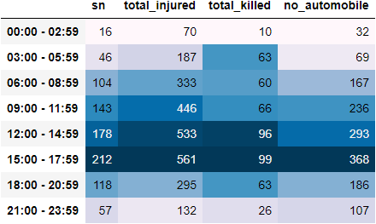

Figure 4.5**:** Accident Cases report on 3-Hour basis

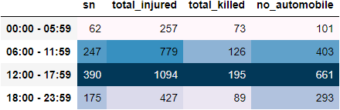

Figure 4.6**:** Accident Cases report on 6-Hour basis

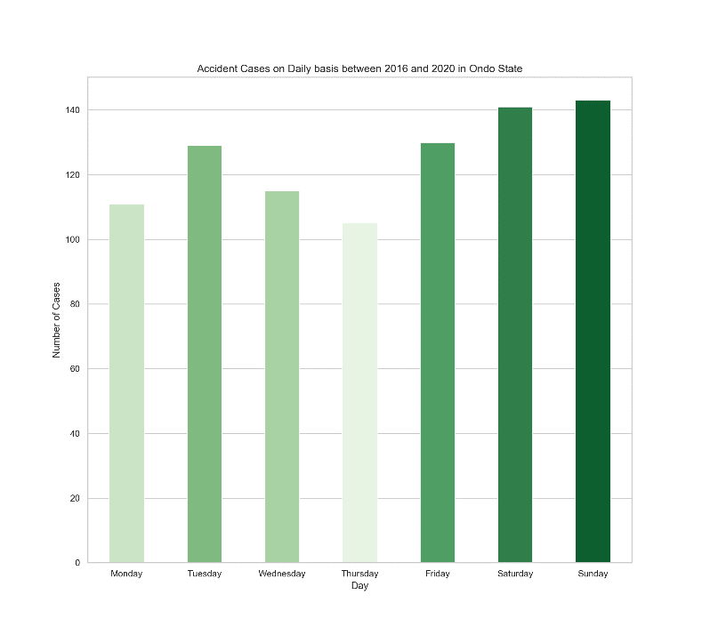

Figure 4.7**:** Daily Accident Cases recorded on a daily basis

**4.1.2 Analysis based on Routes**

For location-based analysis, data is sorted based on the route indicates that most RTAs cases recorded occurs along the Owo-Akure and Ifon-Owo axes compared with other axes in the state.

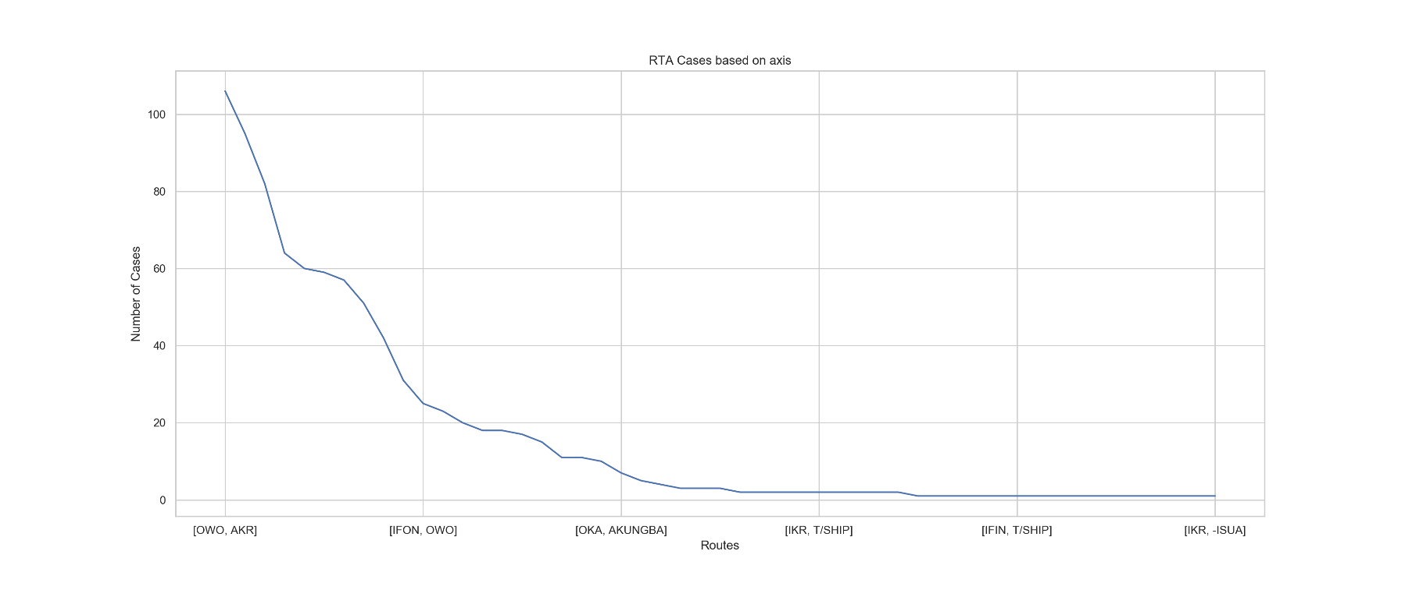

Figure 4.8**:** Routes and number of cases recorded

**4.2 ANN Predictive Model Result**

Based on the architecture of the 3-layer perceptron, tests were carried out on different number of hidden layers in order to intelligently select the one with the best minimum loss. The accuracy of the model was used as a metric; comparing the training result with the validation set. However, 128 neurons were preselected for each of the hidden layers, resulting to 128-29, 128-128-29, 128-128-128-29 architecture. As shown in figure 4.6, the most appropriate architecture was the 128-128-29 and the 128-29. The former was selected, with 128 in the input layer, 128 in the hidden layer, and 29 in the output layer.

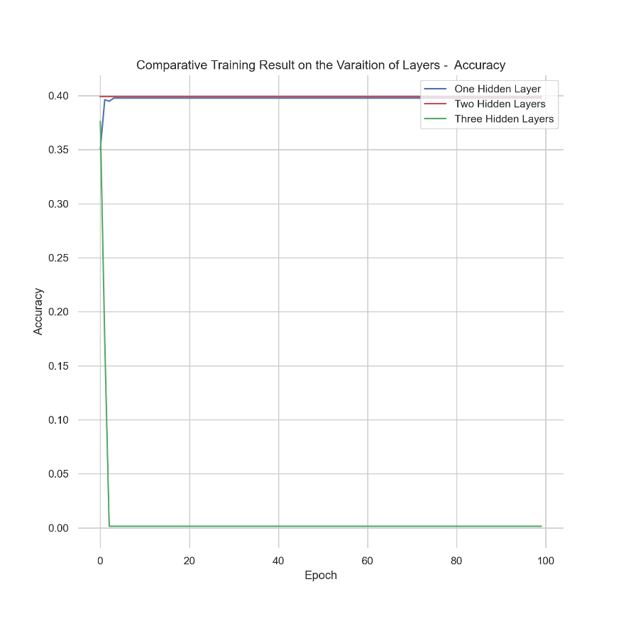

Figure 4.9: Comparing different hidden layers.

From the result obtained, the loss continues to minimize until it gets to about 5 epochs, after which the loss remained constant. The same was also observed with the accuracy as shown in Figure 4.10 and Figure 4.11.

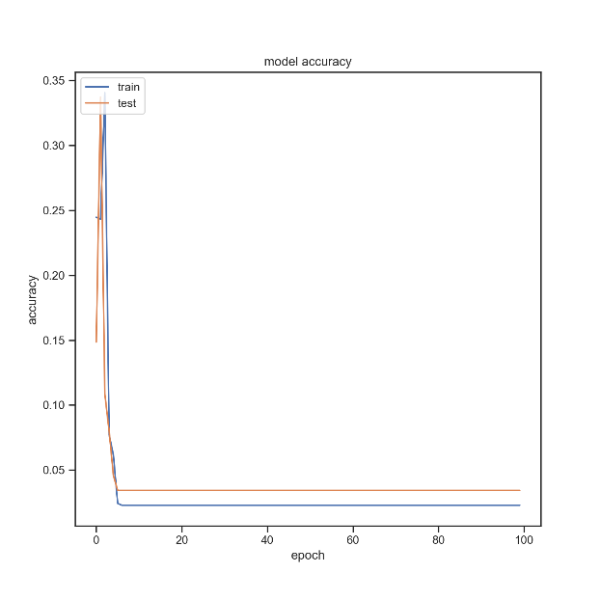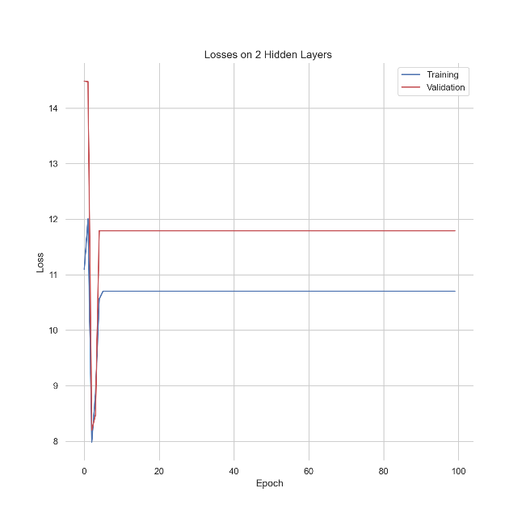

Figure 4.10**:** Accuracy Plot Figure 4.11**:** Loss Plot

**4.2.1 Comparative Results of Test on the variation of Activation Function**

The stability of the ReLU activation function was compared with that of hyperbolic tangent activation function (Tanh) and Scaled Exponential Linear Unit (SELU). The ReLU gave a better accuracy when compared the rest shown in Figure 4.12.

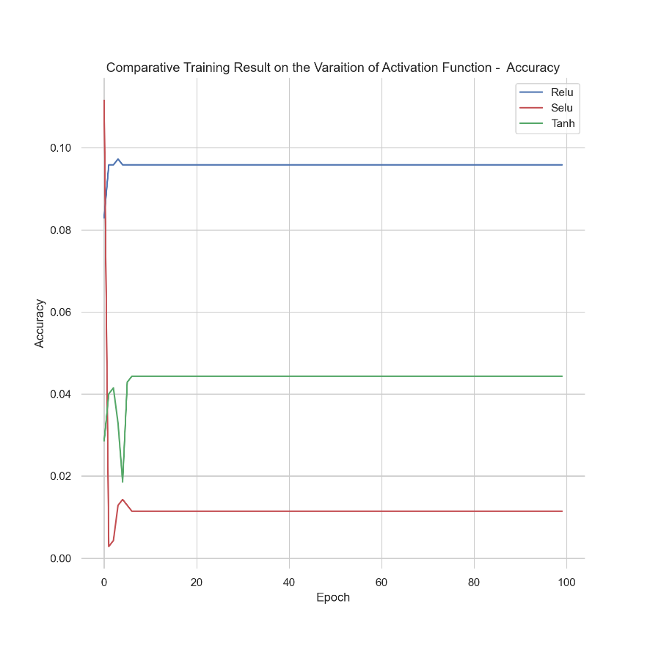

Figure 4.12: Comparative Training Result on the variation of Activation Function

**4.2.2 Comparative Results of Test on the variation of Optimizer**

The Stochastic Gradient Descent (SGD), Root Mean Square Propagation (RMSProp) and Adaptive Moment Estimation (ADAM) were compared. The three (3) optimizers are used to reduce the loss during the training. The ADAM which is similar to RMSProp produced the best result. The optimizer considers the gradient of the current step and accumulates it to the previous step. The result obtained is shown below.

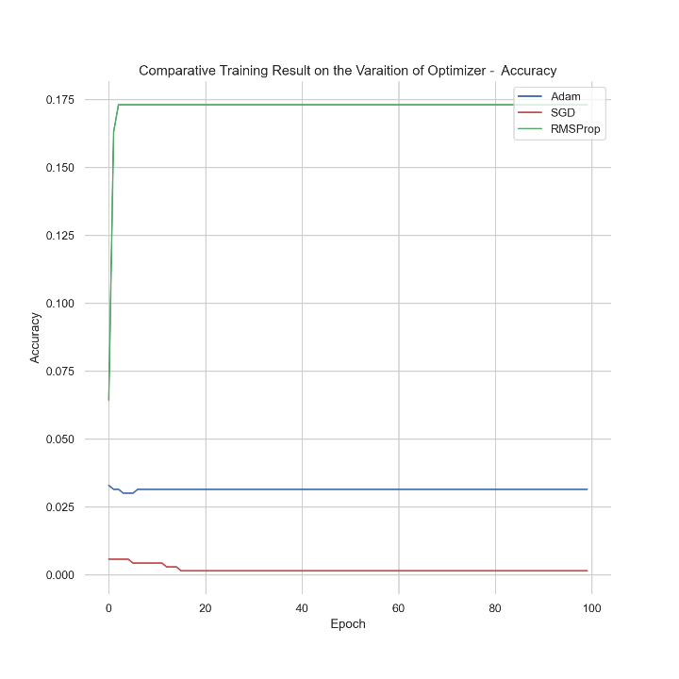

Figure 4.13: Comparative Training Result on the variation of Activation Function

Using the accident cases data collected by the Federal Road Safety Corps (FRSC) in Ondo state, a predictive regression model of the causes of accident has been trained. The available data had information between 2016 and 2020. In the exploration phase, it was possible to identify a close relationship between the various features and the causes of accident. For the construction of the model, a multi-layer artificial neuronal network was selected as it is able to show non-linear relationship. Multiple tests were made that allowed the selection of appropriate hyper-parameters to achieve better results. Given this is a regression problem, the predictive quality of the model was evaluated using the concept of accuracy. Accuracy of 38% was obtained, this is low but this due to the size of data collected, as only few of the accident cases are recorded.

**CHAPTER FIVE**

**CONCLUSION AND RECOMMENDATIONS**

**5.0 Conclusion**

On representation of the secondary data sourced for the purpose of this research via statistical techniques, and training of the Artificial Neural Network model to predict future causes of accidents in Akure, Nigeria, the following conclusion have been drawn.

1. In the five-year span of the study (2016 to 2020), the most RTAs occurred in 2018, with a 29.1% accident percentage cases within this span.
2. More so, in the five-year span of the study, RS. 11.21 unit command recorded the most RTAs. This command accounts for Omotosho axis; NNPC Filling Station; Owena village; MTN Mast Area; Omi Ifon village; and Ore road.
3. It was also deduced that most RTAs occurred in the month of August with over 700 persons involved; 300 persons injured; and about 50 lives lost (on the average) in the month annually.
4. Most RTAs cases occurred between 12pm and 6pm WAT.
5. In addition, most RTA cases in Akure occurred in Sundays, closely followed by cases that occurred on Saturdays, with an average road accidents of about 142 and 140 cases on a daily basis respectively, within the study span.
6. A critical analysis based on routes also showed that most accidents in Akure, Nigeria occurred around Owo and Ifon axes.
7. Importantly, statistical representation of the secondary data showed that speed violation; loss of control; and brake failure were primary and prominent causes of RTAs. In addition, results based on location; route; months of the year; days of the week; and time of the day, can be traced to excessive use of the road by commuters during these periods.
8. The ANN is best suited for showing non-linear relationships like the one under study.
9. The 128-128-29 3-layer perception is the best ANN architecture for modeling and predicting future accident causes.
10. However, the data set available for modeling was quite insufficient and the ANN yielded 38% accuracy. As such, it was impossible to predict future causes of accidents using the ANN.

**5.1 Recommendations**

The following are recommended to mitigate road traffic accidents in Akure, Nigeria.

1. Appropriate government authorities should empower and equip the Federal Road Safety Corps.
2. The FRSC should provide sensitization to citizens on the importance of automobile/vehicle maintenance.
3. FRSC personnels should permanently be on roads to transparently check for regular/updated vehicle maintenance and adherence to road/traffic rules and regulations.
4. Checkpoints and security should be beefed-up at locations; routes; months of the year; days of the week; and time of the day that have been deduced to experience most road accident cases.
5. Ambulances and first-aid services should be provided on roads to rescue casualties of RTAs.
6. Importantly, the FRSC should keep accurate data, and be ready to provide such data for purpose of research as this.

**REFERENCES**

Abdelwahab, H., and Abdel-Aty, M. (2001). Development of ANN Models to Predict Driver Injury Severity in Traffic Accidents at Signalized Intersections, Transport. Res. Rec., 1746, pp. 6-13

Adeolu J. (1993). Road Accident Trends in Nigeria. Accident Analysis and Prevention. 25(4), pp. 485-487

Agarwal R. (2010). Advantages and Disadvantages of Road Transport (Retrieved from: <https://www.yourarticlelibrary.com/geography/transportation/advantages-and-disadvantages-of-road-transport/42135>)

Bennet, Coleman and Co. Ltd. (2021). Definition of Road Transportation. (Available on: <https://economictimes.indiatimes.com/definition/Road-transport>)

Borja G., Andreas B., Markus D., and Bryan T. (2018). Predicting Road Traffic Accidents using Artificial Neural Network Models.

David (2000). Modes of Transportation – Unit 8

David B. (n.d). Transportation Systems. Transportation Engineering and Planning – Vol 1.

David L., Henry L., William G., Adam D., and Michael C. (2009). Fundamentals of Transportation.

DFT (2011). Strategic Framework for Road Safety. Department for Transport. London.

Dostál I., and Adamec V. (n.d). Transport and its Role in the Society. Transactions on Transport Sciences – Volume 4

El-Basyouny K., and Sayed, T. (2011). A full Bayes multivariate intervention model with random parameters among matched pairs for before–after safety evaluation. Accident Analysis & Prevention, 43(1), 87-94.

Federal Road Safety Corps. Policy, Research, and Statistics Department, Abuja. Road Transport Causes Casualty Information Form.

Gbadamosi, K. (2015). Spatial Trend and Management of Road Traffic Fatalities in Nigeria, Academic Journal of Interdisciplinary Studies MCSER Publishing, Rome-Italy

Gurney K. (1997). An Introduction to Neural Networks

Jean-Paul R., Claude C., and Brian S. (2006). The Geography of Transport Systems.

Malik F. (2017). Road Accidents and Prevention. IJEDR | Volume 5, Issue 2 | ISSN: 2321-9939

Mohd Z. (2011). Development of Accident Prediction Model by Using Artificial Neural Network (Ann).

Muhammed N., and Peter S. (2016). Analyzing Factors Responsible For Road Traffic Accidents along Kano-Kaduna-Abuja Dual Carriageway Nigeria. Journal of Economics and Sustainable Development.

Odumosu, A. (2005). Demeanour Transposition as Strategy for Traffic Accident Reduction in Nigeria: Case Study of Niger State, Nigeria, Proc. 13th International Conference on Road Safety on Four Continents, Warsaw, Poland, p. 18

Ogwueleka F., Misra S., Ogwueleka T., and Fernandez-Sanz L. (2014). An Artificial Neural Network Model for Road Accident Prediction: A Case Study of a Developing Country. Acta Polytechnica Hungarica.

Ohakwe J., Iwueze, I., and Chikezie, D. (2011). Analysis of Road Traffic Accidents in Nigeria: A Case study of Obinze/Nekede/Iheagwa Road in Imo State, southeastern, Nigeria. Asian Journal of applied Sciences, 4(2): pp. 166-175

Oluwaseyi A., and Gbadamosi T. (2017). Road Traffic Crashes in Nigeria: Causes and Consequences. Transport & Logistics: the International Journal

Osime, O., Ehikhamenor, E., Oludiran, O., Iribhogbe, P., Ighedosa, S., and Elusoji, S. (2006). Road Traffic Accident Trends in Nigeria. International Journal of Injury Control and Safety Promotion, 13(4), pp. 251-253

Ozgan, E., and Demirci R. (2008). Neural Networks-based Modeling of Traffic Accidents in Interurban Rural Highways, duzce sampling. J. Applied Sci., 8: 146-151

Pande, A., and Abdel-Aty, M. (2006). Assessment of Freeway Traffic Parameters Leading To Lane-Change Related Collisions. Accident Analysis and Prevention. 38, pp. 936-948

Richard M., and Bridget B. (2002). Consequences of Road Traffic Accidents for different Types of Road User. International Journal of the Care of the Injured.

Tchanche B. (2019). A view of road transport in Africa. African Journal of Environmental Science and Technology.

**Appendix**

Data Preprocessing

#!/usr/bin/env python

# coding: utf-8

import pandas as pd

import numpy as np

import matplotlib.pyplot as plt

import re

import datetime

import time

import seaborn as sns

pd.set_option('display.max_rows', None)

pd.set_option('display.max_columns', None)

df2016 = pd.read_csv('data/rtc_2016.csv')

df2017 = pd.read_csv('data/rtc_2017.csv')

df2018 = pd.read_csv('data/rtc_2018.csv')

df2019 = pd.read_csv('data/rtc_2019.csv')

df2020 = pd.read_csv('data/rtc_2020.csv')

# #### Aggregate Data

total_df = pd.concat([df2016,df2017,df2018,df2019,df2020], ignore_index=True)

total_df.drop('Unnamed: 0', inplace=True, axis=1)

total_df.replace(0, np.nan, inplace=True)

# Keep only the rows with at least 2 non-NA values.

total_df.dropna(subset=["crash_time","report_time", "arrival_time","total_involved","causes"],inplace=True)

# #### Time Splitter and Cleaner Function

new_crash_time = total_df['crash_time'].astype(str).apply(lambda x: re.sub("[^0-9]", "", x))

new_arrival_time = total_df['arrival_time'].astype(str).apply(lambda x: re.sub("[^0-9]", "", x))

new_response_time = total_df['response_time'].astype(str).apply(lambda x: re.sub("[^0-9]", "", x))

# In[577]:

total_df['crash_time'] = new_crash_time.apply(np.int64)

# In[578]:

total_df['arrival_time'] = new_arrival_time.apply(np.int64)

# In[579]:

total_df['report_time'] = total_df['report_time'].round(0).astype(int)

# In[580]:

total_df['date'] = total_df['date'].astype(str)

# In[581]:

def clean_date(date_given):

    try:

        return pd.to_datetime(date_given,errors="coerce")

    except:

        return '0'

# In[582]:

total_df['date'] = total_df['date'].apply(lambda x: clean_date(x))

# In[583]:

# Four(4 Data Points with missing date)

total_df[np.isnat(total_df['date'])]

# In[584]:

total_df['month'] = pd.to_numeric(total_df['date'].dt.month.astype(int, errors='ignore'))

total_df['day'] = pd.to_numeric(total_df['date'].dt.day.astype(int, errors='ignore'))

total_df['year'] = pd.to_numeric(total_df['date'].dt.year.astype(int, errors='ignore'))

# In[585]:

total_df['month'].fillna(method='bfill',inplace=True)

total_df['day'].fillna(method='bfill', inplace=True)

total_df['year'].fillna(method='bfill', inplace=True)

# In[586]:

total_df['year'] = total_df['year'].apply(np.int64)

total_df['month'] = total_df['month'].apply(np.int64)

total_df['day'] = total_df['day'].apply(np.int64)

# In[587]:

def fill_missing_date(date, year, month, day):

    if pd.isnull(date):

        new_date = datetime.datetime(year=year, month=month, day=day)

        return new_date

    else:

        return date

# In[588]:

total_df['date'] = total_df.apply(lambda x:fill_missing_date(x['date'], x['year'], x['month'], x['day']), axis=1)

# In[589]:

total_df['crash_time'].apply(lambda x: len(str(x))).unique()

# In[590]:

total_df['report_time'].apply(lambda x: len(str(x))).unique()

# In[591]:

total_df['arrival_time'].apply(lambda x: len(str(x))).unique()

# In[592]:

total_df['response_time'].apply(lambda x: len(str(x))).unique()

# In[593]:

total_df[total_df['crash_time'].astype(str).map(len)==5]

# In[594]:

total_df[total_df['report_time'].astype(str).map(len)==5]

# In[595]:

total_df.loc[total_df['crash_time'].astype(str).map(len)==5, 'crash_time'] = 1123

# In[596]:

total_df.loc[total_df['report_time']==7855, 'report_time'] = 1855

# In[597]:

total_df.loc[total_df['report_time'].astype(str).map(len)==5, 'report_time'] = 1213

# In[598]:

total_df

# In[599]:

def time_splitter(time):

    to_string = str(time)

    if len(to_string) == 2:

        return pd.to_datetime("00" + ":" + str(time), format= '%H:%M')

    elif len(to_string) == 3:

        return pd.to_datetime(to_string[0] +":" + to_string[1:], format= '%H:%M')

    elif len(to_string) == 4:

        return pd.to_datetime(to_string[0:2] + ":"+ to_string[2:], format= '%H:%M')

    else:

        return pd.to_datetime(str(time), format= '%H:%M')

# In[600]:

total_df['crash_time'] = total_df['crash_time'].apply(lambda x:time_splitter(x)).dt.time

# In[601]:

total_df['report_time'] = total_df['report_time'].apply(lambda x:time_splitter(x)).dt.time

# In[602]:

total_df['arrival_time'] = total_df['arrival_time'].apply(lambda x:time_splitter(x)).dt.time

# In[603]:

def combine_date_time(date, time):

    return datetime.datetime.combine(date, time)

def subtract_date_time(start, end):

    return end - start

# In[604]:

crash_datetime = total_df.apply(lambda x: combine_date_time(x['date'], x['crash_time']), axis=1)

report_datetime = total_df.apply(lambda x: combine_date_time(x['date'], x['report_time']), axis=1)

arrival_datetime = total_df.apply(lambda x: combine_date_time(x['date'], x['arrival_time']), axis=1)

# In[605]:

total_df['report_minus_crash'] =  subtract_date_time(crash_datetime, report_datetime).apply(lambda x:x.total_seconds()).astype(int)

# In[606]:

total_df['arrival_minus_crash'] =  subtract_date_time(crash_datetime, arrival_datetime).apply(lambda x:x.total_seconds()).astype(int)

# In[607]:

total_df["arrival_minus_report"] =  subtract_date_time(report_datetime, arrival_datetime).apply(lambda x:x.total_seconds()).astype(int)

# In[608]:

total_df['datetime'] = pd.to_datetime(crash_datetime)

# In[609]:

total_df.replace(np.nan, 0, inplace=True)

# In[610]:

total_df['fleet_operator'] = total_df['fleet_operator'].replace(0, np.nan)

total_df['name_of_driver'] = total_df['name_of_driver'].replace(0, np.nan)

total_df['dl_no'] = total_df['dl_no'].replace(0, np.nan)

# In[611]:

total_df['vehicle_type']

# In[612]:

def get_automobile_no(car_det):

    try:

        # print(car_det)

        # Split the various car category

        car_det = car_det.split('&')

        all_g= []

        automobile_no = 0

        # Iterate through each item

        for item in car_det:

            item = item.strip()

            # Separate inner lists

            item = re.split(',| * ',item)

            # Iterate through the inner loop and add to the primary list

            if type(item) is list:

                for val in item:

                    val = val.strip()

                    if val not in ["","*",'HIT','RUN', '(HIT', 'RUN)']:

                        all_g.append(val)

            # Iterate through ther list generate including the numbers

        for each in all_g:

            if each.isdigit():

                each = int(each)

                automobile_no += each - 1

            else:

                automobile_no +=1

        if automobile_no < 1:

            return 0

        else:

            return automobile_no

    except:

        return 0

# In[613]:

total_df['no_automobile'] = total_df.apply(lambda x: get_automobile_no(x['vehicle_cat']), axis=1)

# In[614]:

total_df['route'] = total_df['route'].str.strip()

# In[615]:

total_df[total_df['vehicle_cat']== '3COM']

# In[616]:

total_df.to_csv('data/cleaned_aggregated.csv', index=False)

# In[617]:

c.columns

**II ANN Modelling**

#!/usr/bin/env python

# coding: utf-8

# In[14]:

import pandas as pd

import numpy as np

import matplotlib.pyplot as plt

import seaborn as sns

sns.set(rc={'figure.figsize':(11.7,8.27)})

pd.set_option('display.max_rows', None)

pd.set_option('display.max_columns', None)

get_ipython().run_line_magic('matplotlib', 'inline')

sns.set(rc={"figure.dpi":150, 'savefig.dpi':200})

sns.set_context('notebook')

sns.set_style("ticks")

plt.rcParams['figure.dpi'] = 150

plt.rcParams['savefig.dpi'] = 200

from IPython.display import set_matplotlib_formats

set_matplotlib_formats('svg')

# In[15]:

df = pd.read_csv('data/cleaned_august.csv')

# In[16]:

df.drop(['key_0'], inplace=True, axis=1)

# In[17]:

Z_data = df

# In[18]:

Z_data

# In[19]:

X = Z_data.drop(Z_data.columns[31:], axis=1)

y = Z_data[Z_data.columns[31:]]

# In[20]:

from sklearn.model_selection import StratifiedShuffleSplit,train_test_split

X_train, X_test, y_train, y_test = train_test_split(X, y, test_size = 0.2, random_state=42)

# In[21]:

y_train  = y_train.reindex(sorted(y_train.columns), axis=1)

y_test  = y_test.reindex(sorted(y_test.columns), axis=1)

# ### Train

# In[22]:

Z_train = X_train

# In[23]:

X_train.shape

# In[24]:

from sklearn.preprocessing import LabelBinarizer

lb3 = LabelBinarizer()

lb4 = LabelBinarizer()

binarized3 = pd.DataFrame(lb3.fit_transform(Z_train['route:from']), columns=['from:'+a for a in list(lb3.classes_)])

binarized4 = pd.DataFrame(lb4.fit_transform(Z_train['route:to']), columns=['to:'+a for a in list(lb4.classes_)])

# In[25]:

def fix_duplicates(first, last):

    if first==1 or last==1:

        return 1

    elif first==0 and last==0:

        return 0

# In[26]:

binarized4['to:ONDO'] = binarized4.apply(lambda x:fix_duplicates(x['to:ONDO'], x['to:OND']),axis=1)

binarized4['to:ISUA'] = binarized4.apply(lambda x:fix_duplicates(x['to:ISUA'], x['to:-ISUA']),axis=1)

binarized4['to:ORE'] = binarized4.apply(lambda x:fix_duplicates(x['to:ORE'], x['to:-ORE']),axis=1)

binarized4['to:OWO'] = binarized4.apply(lambda x:fix_duplicates(x['to:OWO'], x['to:OWO']),axis=1)

binarized4['to:IPT'] = binarized4.apply(lambda x:fix_duplicates(x['to:IPT'], x['to:-IPT']),axis=1)

binarized4['to:AJOWA'] = binarized4.apply(lambda x:fix_duplicates(x['to:AJOWA'], x['to:AJW']),axis=1)

binarized4['to:OKITIPUPA'] = binarized4.apply(lambda x:fix_duplicates(x['to:OKITIPUPA'], x['to:OKT']),axis=1)

binarized4['to:OKITIPUPA'] = binarized4.apply(lambda x:fix_duplicates(x['to:OKITIPUPA'], x['to:KTP']),axis=1)

binarized3['from:IFON'] = binarized3.apply(lambda x:fix_duplicates(x['from:IFON'], x['from:IFIN']),axis=1)

binarized3['from:ONDO'] = binarized3['from:ONDO'] +  binarized3['from:OND']

binarized4['to:ONDO'] = binarized4['to:ONDO'] +  binarized4['to:OND']

binarized4['to:T/SHIP'] = binarized4['to:T/SHIP'] +  binarized4['to:TSHIP']

# In[27]:

binarized4.drop(['to:-IPT','to:-ISUA','to:OND','to:-OND','to:-ORE','to:TSHIP','to:0','to:AJW','to:OKT','to:KTP'], axis=1, inplace=True)

binarized3.drop(['from:OND','from:0','from:IFIN'], axis=1, inplace=True)

# In[28]:

Z_trained = pd.merge(Z_train, binarized3, how='left', on = Z_train.index)

Z_trained.drop('key_0',axis=1, inplace=True)

# In[29]:

Z_trained = pd.merge(Z_trained, binarized4, how='left', on = Z_train.index)

Z_trained.drop(['route:from','route:to'],axis=1, inplace=True)

Z_trained.drop(['key_0'], inplace=True,axis=1)

Z_trained =Z_trained.reindex(sorted(Z_trained.columns), axis=1)

# In[30]:

Z_trained

# ### Test

# In[31]:

X_test.shape

# In[32]:

Z_t = X_test

# In[33]:

lb10 = LabelBinarizer()

lb11 = LabelBinarizer()

binarized10 = pd.DataFrame(lb10.fit_transform(Z_t['route:from']), columns=['from:'+a for a in list(lb10.classes_)])

binarized11 = pd.DataFrame(lb11.fit_transform(Z_t['route:to']), columns=['to:'+a for a in list(lb11.classes_)])

# In[34]:

def fix_duplicates(first, last):

    if first==1 or last==1:

        return 1

    elif first==0 and last==0:

        return 0

# In[35]:

binarized11['to:AJOWA'] = binarized11.apply(lambda x:fix_duplicates(x['to:AJOWA'], x['to:AJW']),axis=1)

binarized11['to:ONDO'] = binarized11.apply(lambda x:fix_duplicates(x['to:ONDO'], x['to:OND']),axis=1)

# In[36]:

binarized11.drop(['to:OND','to:-OWO','to:AJW' ], axis=1, inplace=True)

binarized10.drop(['from:OND'], axis=1, inplace=True)

# In[37]:

Z_test = pd.merge(Z_t, binarized10, how='left', on = Z_t.index)

Z_test.drop('key_0',axis=1, inplace=True)

# In[38]:

Z_test = pd.merge(Z_test, binarized11, how='left', on = Z_t.index)

# In[39]:

Z_test.drop(['route:from','route:to'],axis=1, inplace=True)

# In[40]:

Z_test.set_index('key_0', inplace=True)

# In[41]:

Z_test.rename(columns={"to:KTP": "to:OKITIPUPA"}, inplace=True)

# In[42]:

Z_test['to:IWARO'] = 0

Z_test['to:IKARAM'] = 0

Z_test['to:IFON'] = 0

Z_test['to:IJEBU'] = 0

Z_test['to:IDOANI'] = 0

Z_test['to:IBOROPA'] = 0

Z_test['to:AUCHI'] = 0

Z_test['to:ARIMOKIJA'] = 0

Z_test['from:IMORU'] = 0

# In[43]:

Z_test =Z_test.reindex(sorted(Z_test.columns), axis=1)

# In[44]:

X_test = Z_test

# In[45]:

X_test.reset_index(inplace=True)

# In[46]:

X_test.drop(['key_0'],axis=1, inplace=True)

# In[47]:

X_test.shape

# ### Model Training

# In[48]:

from sklearn.pipeline import Pipeline

from sklearn.preprocessing import MinMaxScaler

from sklearn.compose import ColumnTransformer

from sklearn.feature_extraction.text import CountVectorizer, TfidfVectorizer

from sklearn.ensemble import RandomForestClassifier

from sklearn.linear_model import LinearRegression

from sklearn.model_selection import GridSearchCV

# In[49]:

import tensorflow as tf

import tensorflow.keras as keras

from keras.wrappers.scikit_learn import KerasClassifier

from keras.models import Sequential

from keras.layers import Dense

# In[50]:

Z_trained.drop(['vehicle_no'],axis=1, inplace=True)

X_test.drop(['vehicle_no'],axis=1, inplace=True)

# In[51]:

len(X_test.columns)

# In[52]:

len(Z_trained.columns)

# In[53]:

X =Z_trained

y = y_train

# In[54]:

X_new = pd.concat([Z_trained, X_test])

y_new = pd.concat([y_train, y_test])

# In[55]:

y_new.shape

# In[56]:

location_vect = TfidfVectorizer()

vehicle_type_vect = TfidfVectorizer()

vehicle_cat = TfidfVectorizer()

vehicle_make = TfidfVectorizer()

vehicle_model = TfidfVectorizer()

ct = ColumnTransformer(

                [('location', location_vect, 'location'),

                 ('vehicle_type', vehicle_type_vect, 'vehicle_type'),

                 ('vehicle_cat', vehicle_cat, 'vehicle_cat'),

                 ('vehicle_make', vehicle_make, 'vehicle_make'),

                 ('vehicle_model', vehicle_model, 'vehicle_model'),

                ],

                 remainder = 'passthrough'

                )

pipe = Pipeline([

                ('tfidf', ct),

])

X = ct.fit_transform(X_new).toarray()

# In[57]:

X[0].shape

# In[58]:

y = y_new.values

# In[59]:

from sklearn.model_selection import train_test_split

X_train, X_test, y_train, y_test = train_test_split(X,y, random_state=42, test_size = 0.3)

# In[ ]:

# In[60]:

# One Hidden Layer

kernel_initializer='glorot_uniform'

ann_model1 = keras.models.Sequential([

        keras.layers.Dense(128, activation='relu',kernel_initializer='uniform', input_dim = X_train.shape[1]),

        keras.layers.Dense(128, activation='relu', kernel_initializer=kernel_initializer),

        keras.layers.Dense(29),

])

print(ann_model1.summary())

# loss and optimizer

loss = keras.losses.CategoricalCrossentropy(from_logits=True)

optim = keras.optimizers.Adam(lr=0.001)

metrics = ['accuracy']

ann_model1.compile(loss = 'categorical_crossentropy', optimizer=optim, metrics=metrics)

batch_size = 4

epochs = 100

model = ann_model1.fit(X_train, y_train,validation_data=(X_test, y_test), batch_size = batch_size, epochs=epochs,verbose=2)

scores = ann_model1.evaluate(X_test,y_test)

print("\n%s: %.2f%%" % (ann_model1.metrics_names[1], scores[1]*100))

ann_model1.save("model.h5")

# In[61]:

# summarize history for loss

f, ax = plt.subplots(figsize=(8, 8))

plt.plot(model.history['accuracy'])

plt.plot(model.history['val_accuracy'])

plt.title('model loss')

plt.ylabel('loss')

plt.xlabel('epoch',)

plt.legend(['train', 'test'], loc='upper left')

ax.set(ylim=(0, 1))

plt.show()

f.savefig("charts/Loss Plot")

# In[62]:

sns.set_theme(style="whitegrid")

# Initialize the matplotlib figure

f, ax = plt.subplots(figsize=(9, 9))

# Plot the total crashes

sns.lineplot(data=model.history['accuracy'],

            label="Training", color="b", markers='*', dashes=False)

sns.lineplot(data=model.history['val_accuracy'],

            label="Validation", color="r", markers=True, dashes=True)

# Add a legend and informative axis label

ax.legend(ncol=1, loc="upper right", frameon=True)

ax.set(ylabel="Accuracy",

       xlabel="Epoch",ylim=(0, 1))

ax.set_title('Accuracy on Training and Validation set', fontsize=13)

sns.despine(left=True, bottom=True)

f.savefig("charts/annresults/original_acc.png")

# In[63]:

sns.set_theme(style="whitegrid")

# Initialize the matplotlib figure

f, ax = plt.subplots(figsize=(9, 9))

# Plot the total crashes

sns.lineplot(data=model.history['loss'],

            label="Training", color="b", markers='*', dashes=False)

sns.lineplot(data=model.history['val_loss'],

            label="Validation", color="r", markers=True, dashes=True)

# Add a legend and informative axis label

ax.legend(ncol=1, loc="upper right", frameon=True)

ax.set(ylabel="Loss",

       xlabel="Epoch")

ax.set_title('Losses of Training and Validation Set ', fontsize=13)

sns.despine(left=True, bottom=True)

f.savefig("charts/annresults/original_loss.png")

# ### Test the prediction model using any index e.g. 30 in this case

# In[64]:

def get_cause(predicted):

    maxim = predicted[0];

    #Loop through the array

    for i in range(0, len(predicted)):

        #Compare elements of array with max

        if(predicted[i] > maxim):

            maxim = predicted[i];

    print(maxim)

    predicted_value = [1 if b == maxim else 0 for b in predicted]

    print(predicted_value)

    match = ['BDR','BFL','BRD','DAD','DGD','DOT','DUI','FEV','FQT','FTG','FTQ','LOC','LSV','MDV','OBS','OTH','OVL','ROB','ROV','RTV','RUN','SLV','SOS','SPV','TBT','TYB','UPD','WOT','WOV']

    location = predicted_value.index(1)

    predicted_abb = match[location]

    causes = pd.read_csv('data/causes_schema.csv',index_col=None)

    for a in causes.values:

        if a[0] == predicted_abb:

            print("The causes of the accident is: ", a[1])

            break

# In[65]:

X_test[59]

expected = y_test[59]

# ### Expected Output

# In[66]:

get_cause(expected)

# ## Prediction Model

# In[67]:

probability_model = keras.models.Sequential([

      ann_model1,keras.layers.Softmax()

])

predictions = probability_model(X_test)

prediction1 = predictions[59]

print(prediction1)

# In[68]:

max(prediction1)

# In[69]:

predicted = prediction1.numpy()

# In[70]:

predicted = list(predicted)

print(predicted)

# #### Prediction

# In[71]:

get_cause(predicted)

# In[ ]: